# Prerequisites

Microsoft Azure subscription must be pay-as-you-go or MSDN.

Resources used as migration source is the localhost which is set up per Appendix A.

All files from <https://github.com/chugugrace/ssis-lab> are downloaded to your local server c:/labfiles.

# What you will accomplish from this lab

* Set up SSIS Integration Runtime in ADF
* Assess SSIS packages
* Execute package in SSIS-IR via SSDT azure mode
* Migrate File System package to Azure file share and execute package in SSIS-IR
* Migrate SSIS catalog packages from SQL server to Azure SQL server
* Migrate agent jobs to ADF pipelines

Note:

The Azure resources provisioned during the lab will be charged.

In Task 10, you will clean up all provisioned resources.

# Task 0: Run ARM template to provision ADF, SSIS IR and Azure SQL Database

In this task, you will run an Azure Resource Manager (ARM) template to deploy the resources required for this hands-on lab. The resources created by the ARM template include:

* An Azure SQL Database server
* An Azure Data Factory
* A SSIS Integration Runtime with SSISDB hosted in Azure SQL Database
* An Azure Storage account, with file shares ‘ssispackages’ and ‘ssislogging’

Reference:

[Azure Resource Manager](https://docs.microsoft.com/azure/azure-resource-manager/resource-group-overview)

[Create an Azure data factory using Azure Resource Manager template](https://docs.microsoft.com/en-us/azure/data-factory/quickstart-create-data-factory-resource-manager-template)

1. In Azure portal, search “deploy custom template” service, then click [Build your own template in the editor](https://ms.portal.azure.com/).

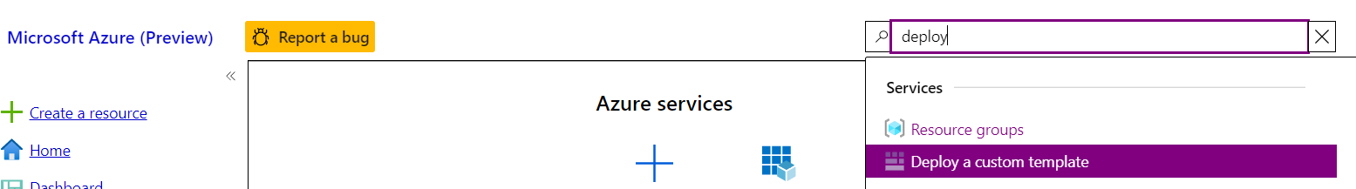

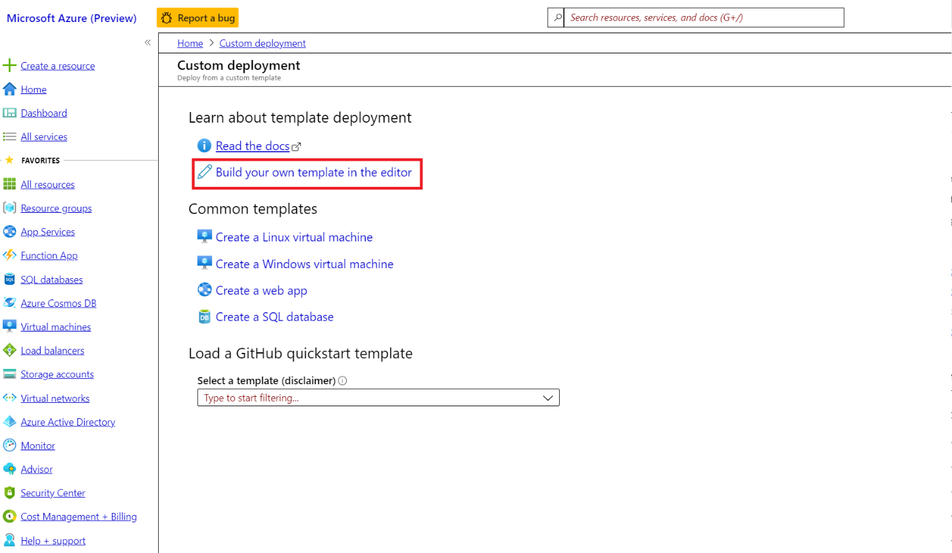

1. Load “adf_ssis_lab_deploy.json” and save.

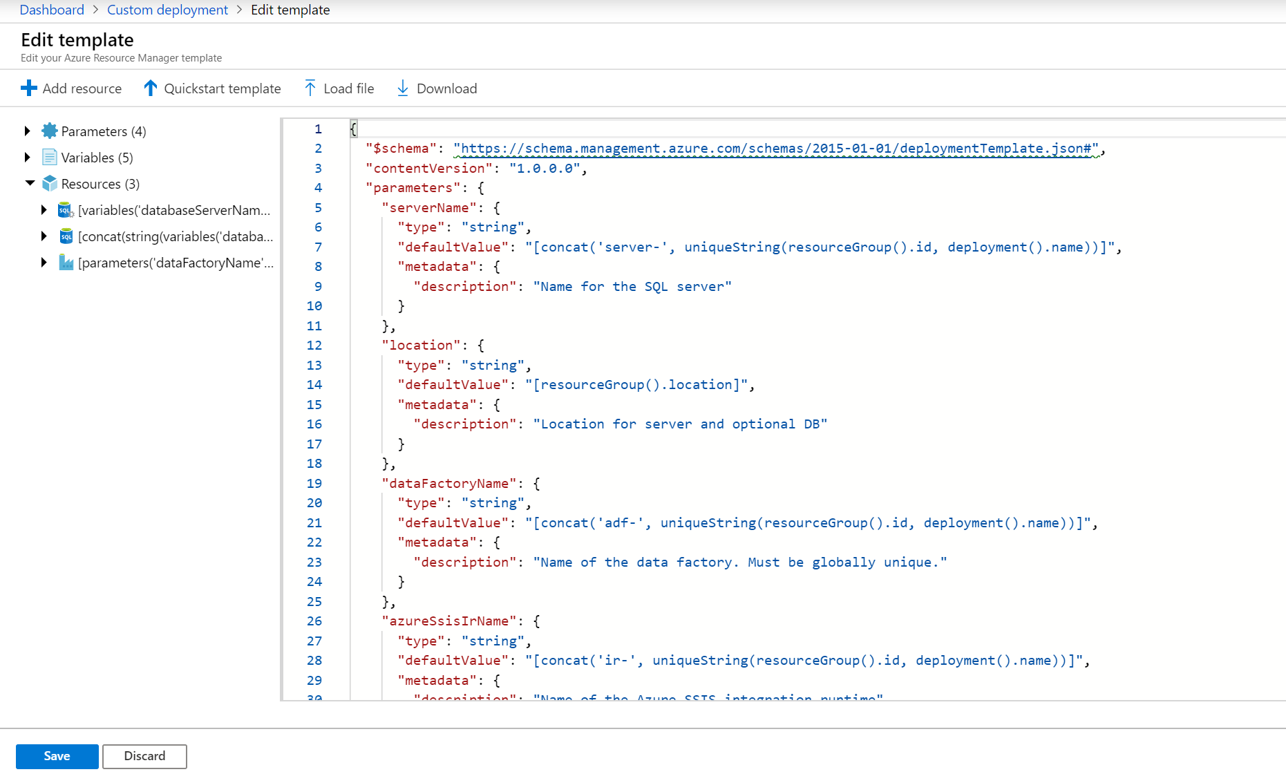

1. On the custom deployment screen in the Azure portal, enter the following:

* **Subscription**: Select the subscription you are using for this hands-on lab.
* **Resource group**: Create a new resource group or select an existing resource group.
* **Location**: Select the location you used for the hands-on-lab resource group.
* **Server Name**: Accept the default value
* **Admin User**: Accept the default value, **LabUser**.
* **Admin Password**: Accept the default value, **pa$$w0rd**.
* **Data Factory Name**: Accept the default value.
* **Azure SSIS IR Name**: Accept the default value.
* **Storage Account Name**: Accept the default value.
* Check the box to agree to the Azure Marketplace terms and conditions.

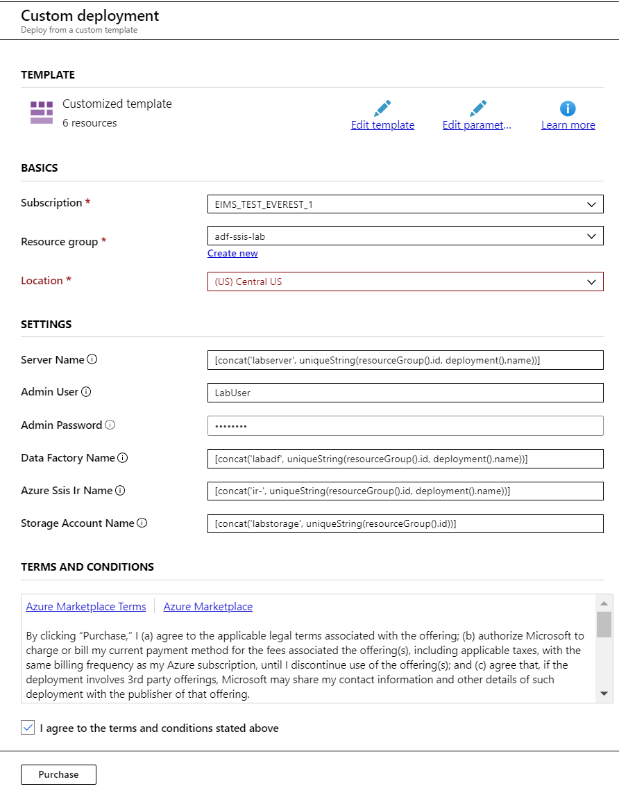

1. Select **Purchase** to start provisioning.
2. You can monitor the progress of the deployment by navigating to the adf-ssis-lab resource group in the Azure portal, and then selecting **Deployments** from the left-hand menu. The deployment will be named **Microsoft.Template**. Select that to view the progress of each item in the template. This step will take several minutes.

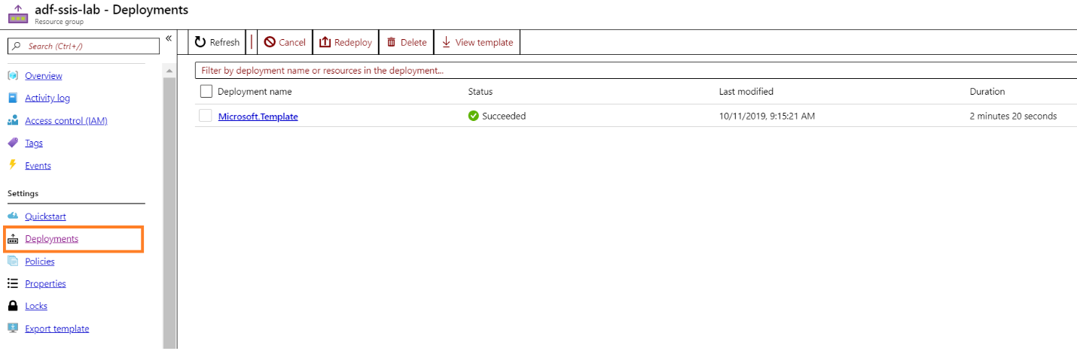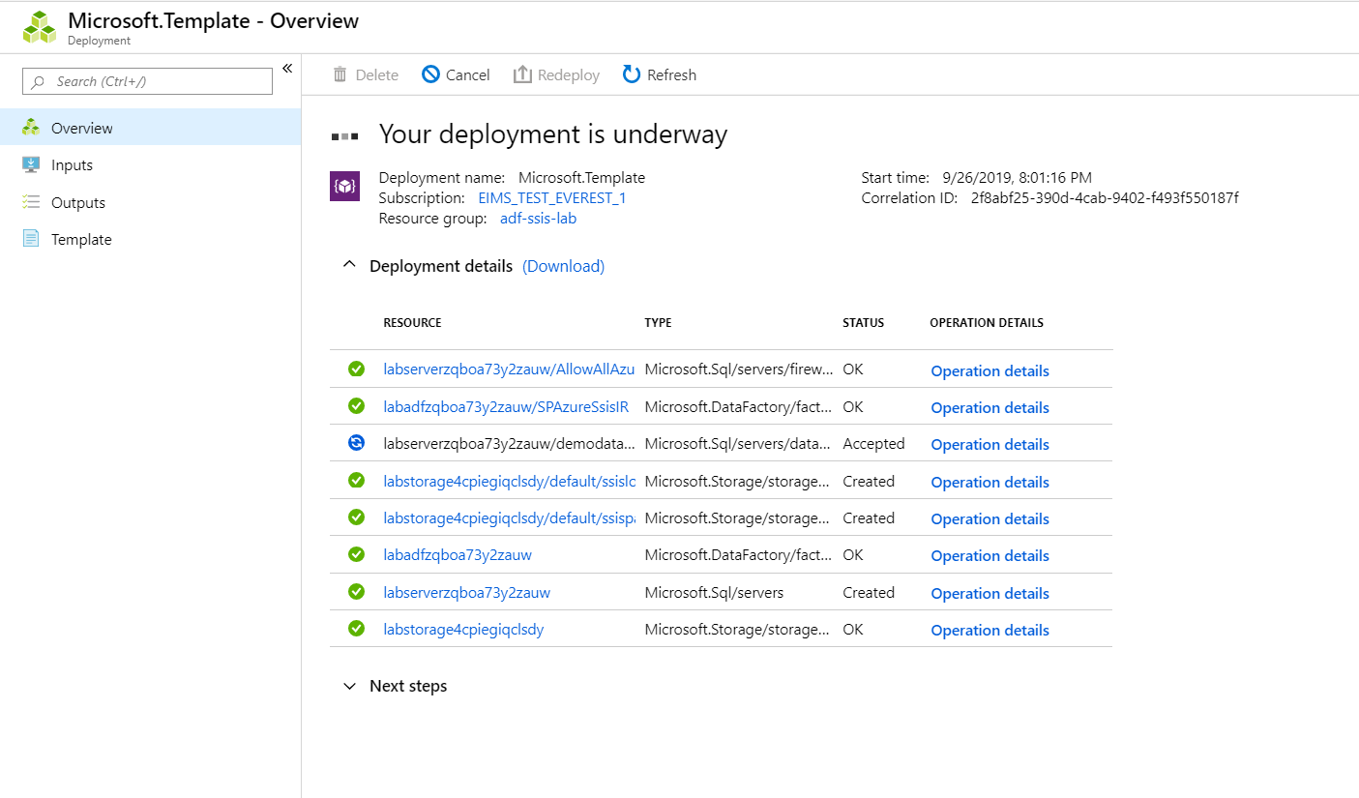

1. After deployment completed, go to resource group to get newly provisioned ADF, SQL Server, and Storage account.

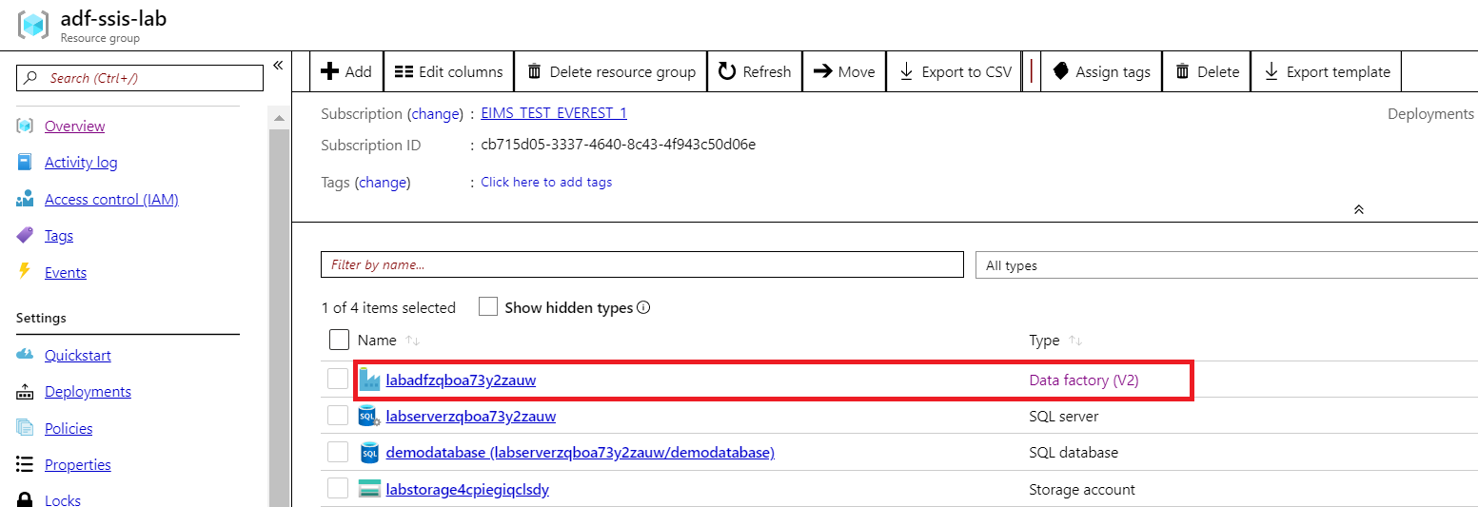

1. Go to ADF resource and launch “Author & Monitor”.

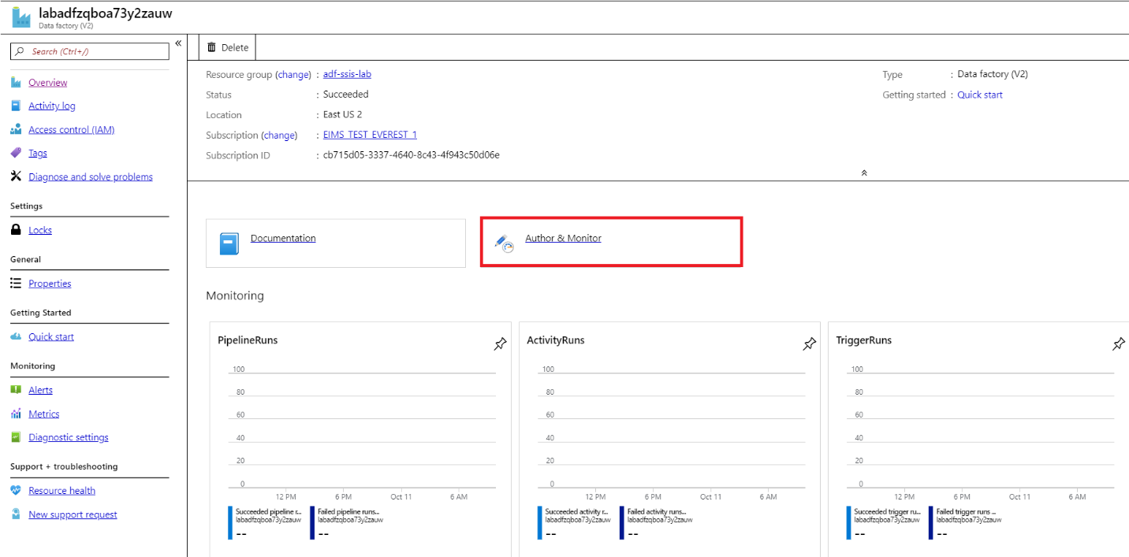

1. Click “Connections” and “Integration Runtimes” tab, start Azure-SSIS.

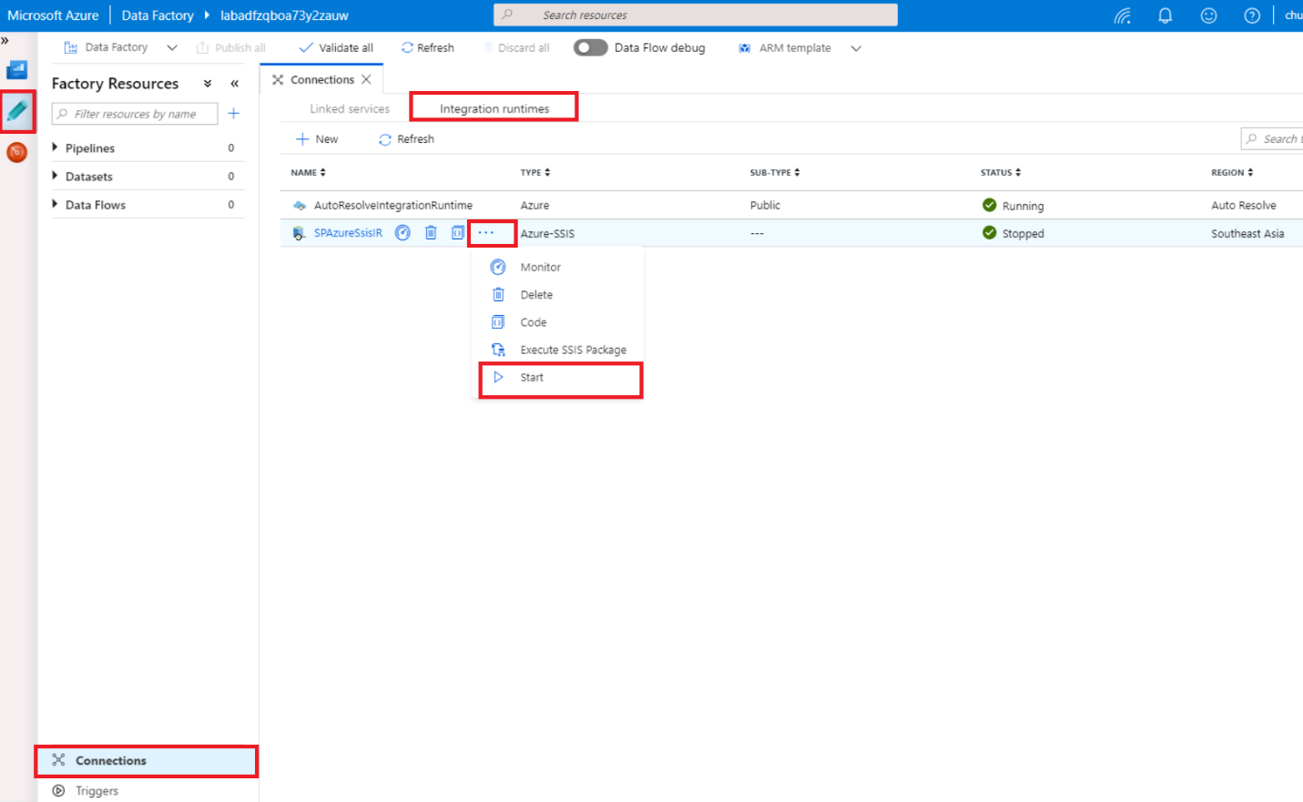

1. Click “Monitor” icon, you can check SSIS Integration Runtime details.

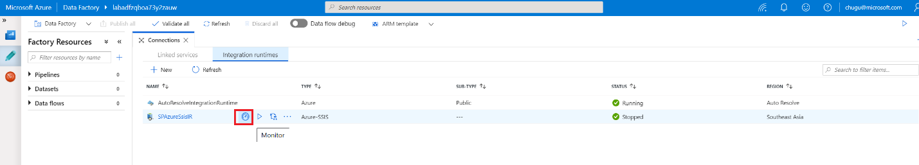

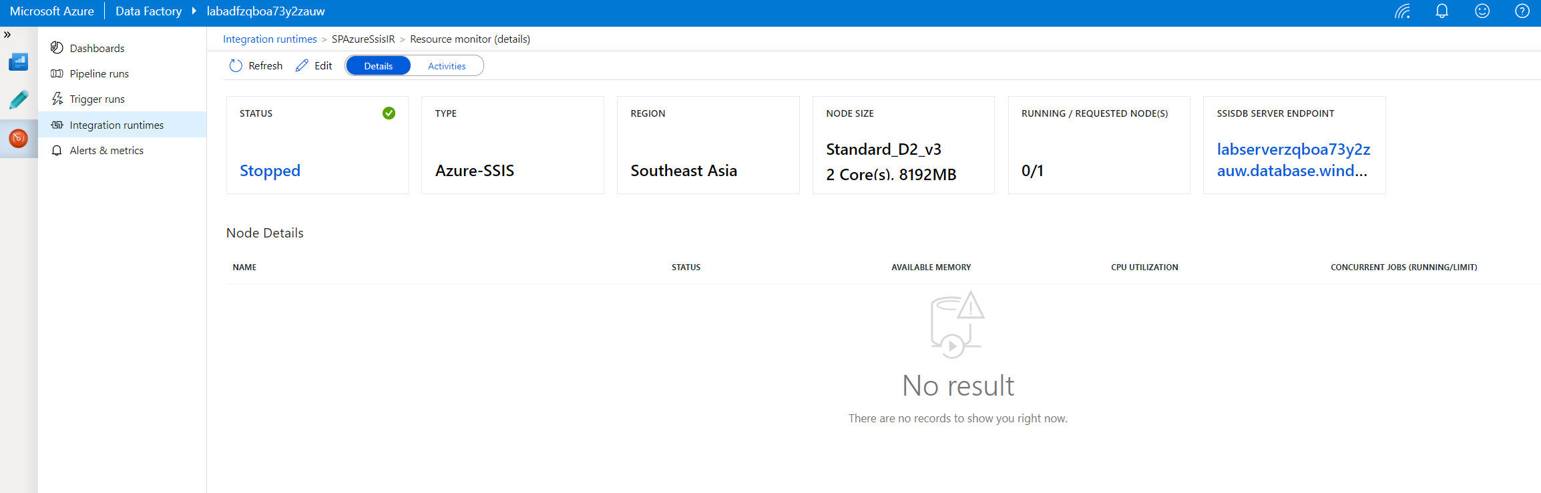

# Task 1: Prepare data to Azure SQL Database

This step is to load demo database under c:\labfiles\demodatabase.bacpac to newly provisioned Azure SQL Database in Task 0.

1. Go to resource group “adf-ssis-lab”, select “SQL server”, then copy “Server name”

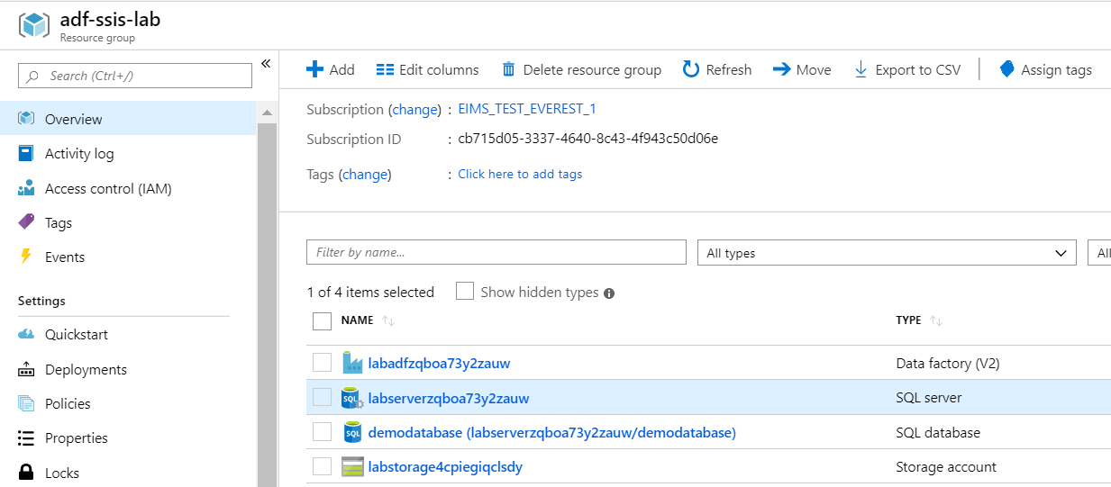

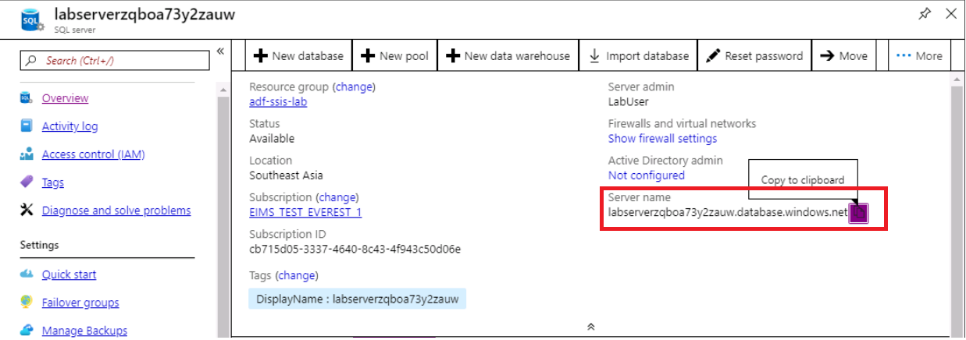

1. Open “SSMS”, connect with “SQL Server Authentication”, Login: LabUser, Password: Pa$$w0rd.

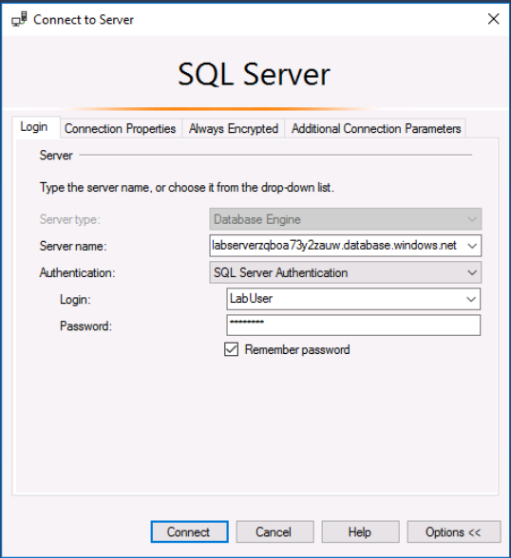

1. You will be prompted to create firewall rule to enable this client ip to access the server, if you have not done this yet.

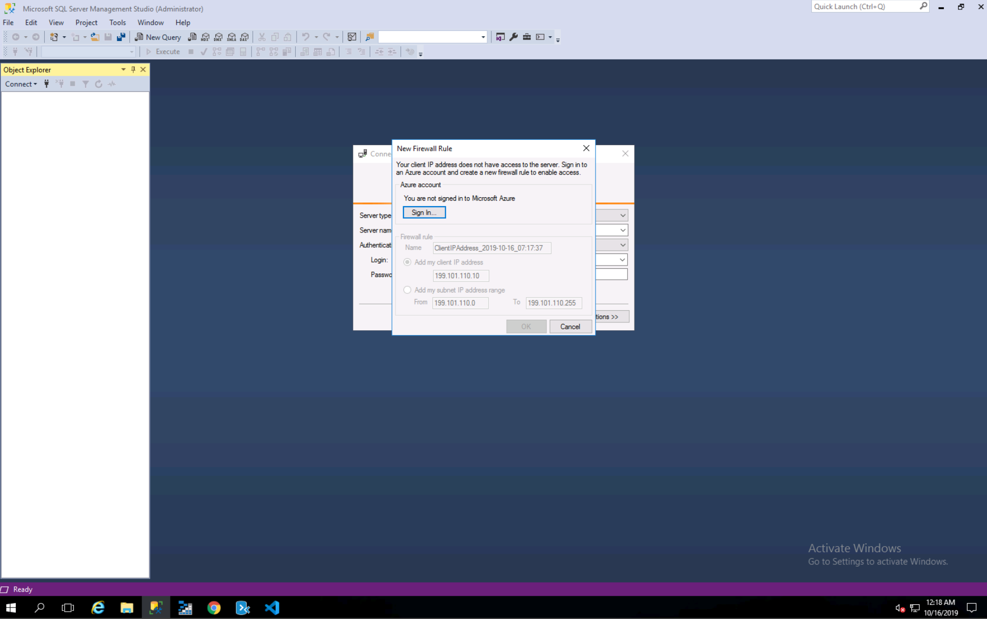

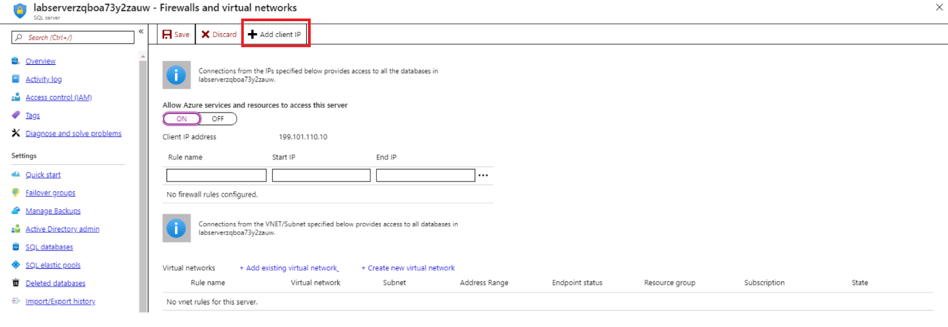

1. Right click “Databases”, then click “Import Data-tier Application …”.

Select c:\labfiles\demodatabase.bacpac to import, then follow the wizard till “Finish”.

You will get Operation Complete result when data is imported completed.

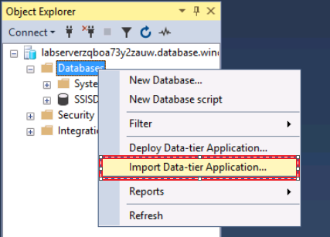

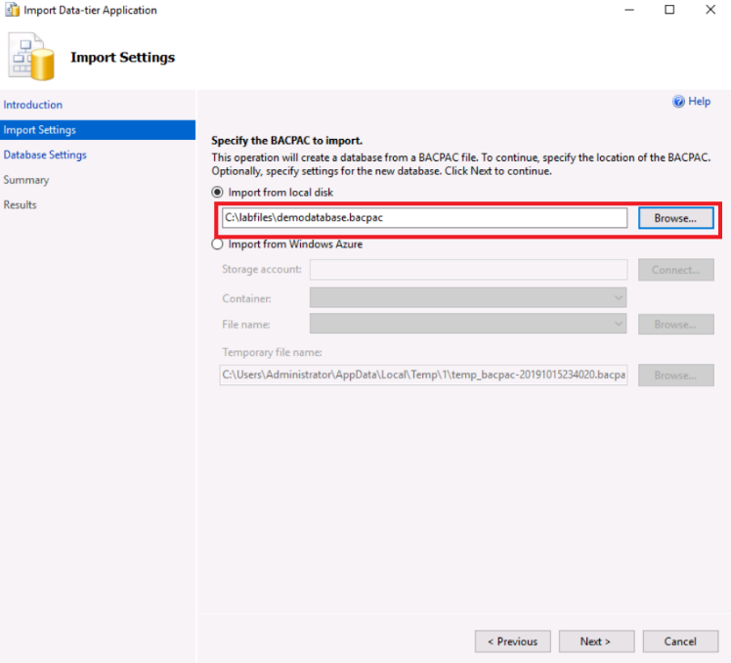

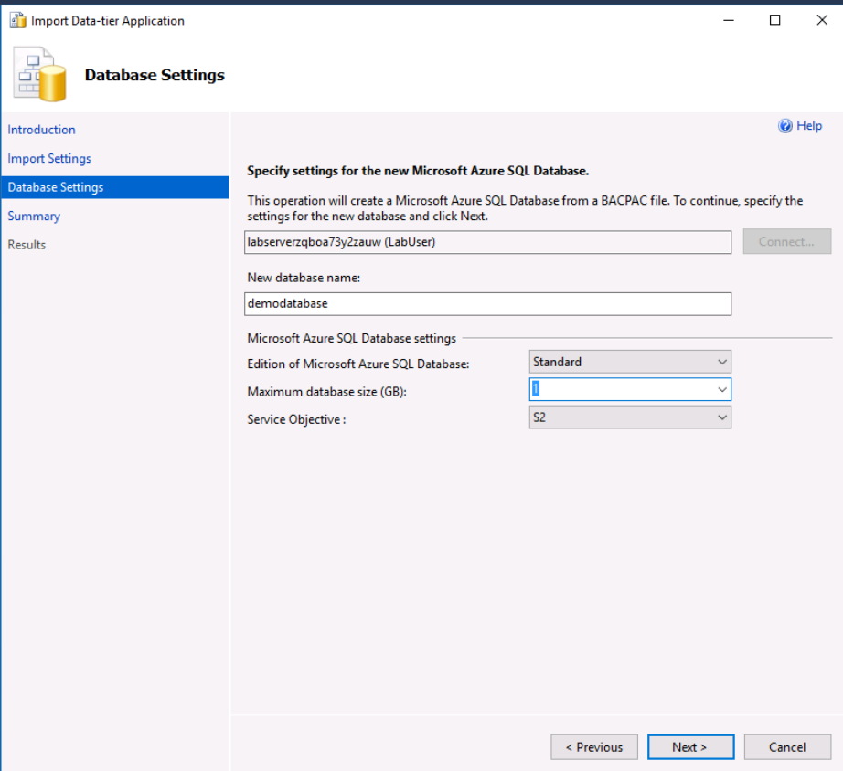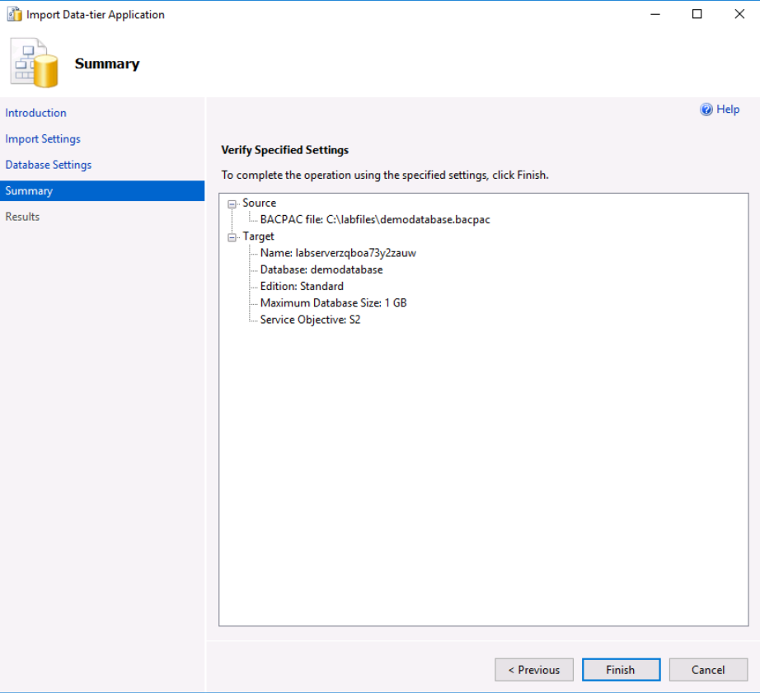

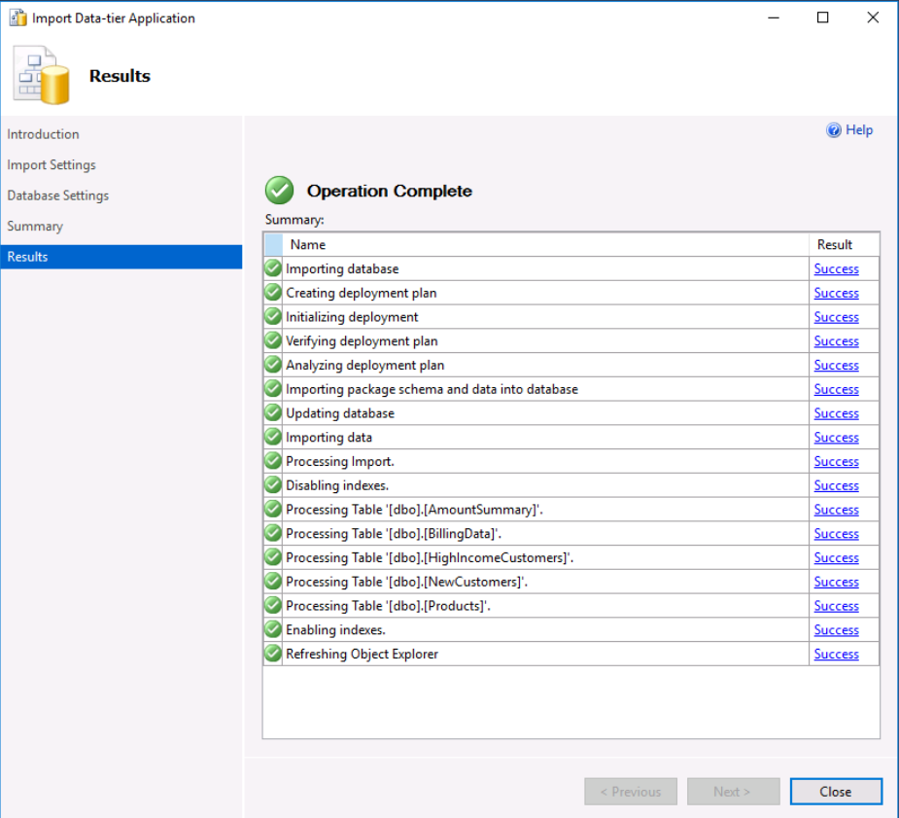

# Task 2: Assessment packages via DMA before migration

In this task, you will use Azure Data Migration Assistant to assess File packages in file system under c:\labfiles\file-system-packages, and SSISDB packages in local database which is set-up before the lab.

Reference: [Perform a SQL Server Integration Service migration assessment with Data Migration Assistant](https://docs.microsoft.com/en-us/sql/dma/dma-assess-ssis)

1. Launch Data Migration Assistant

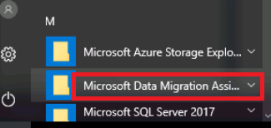

1. Click “+”, input “Project name”, select “Integration Services” as “Assessment type”, then “Create” an assessment project.

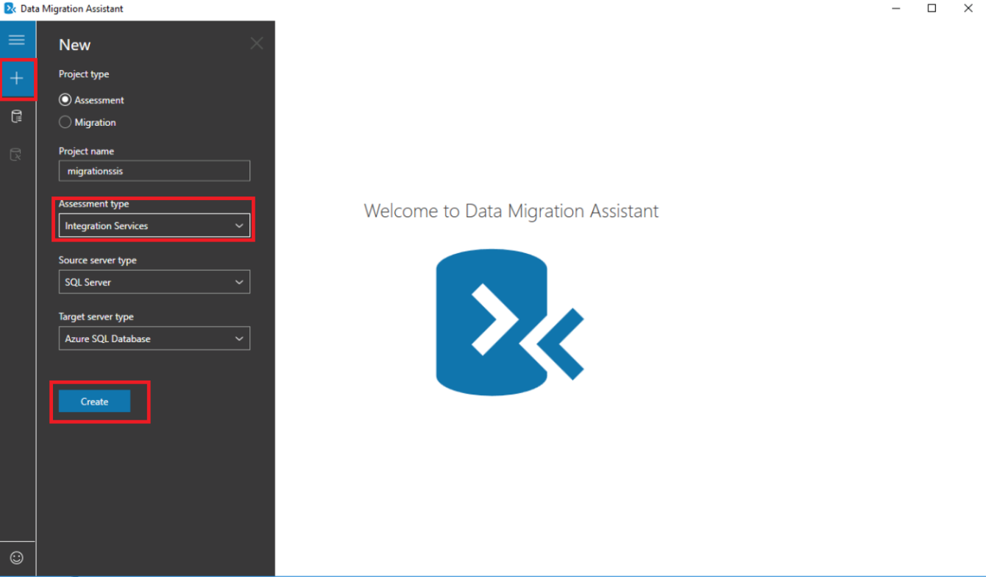

1. Input “Server name”, uncheck “Encryption connection”, input “c:\labfiles\file-system-packages” in folder path, then click “Connect” to localhost as source server.

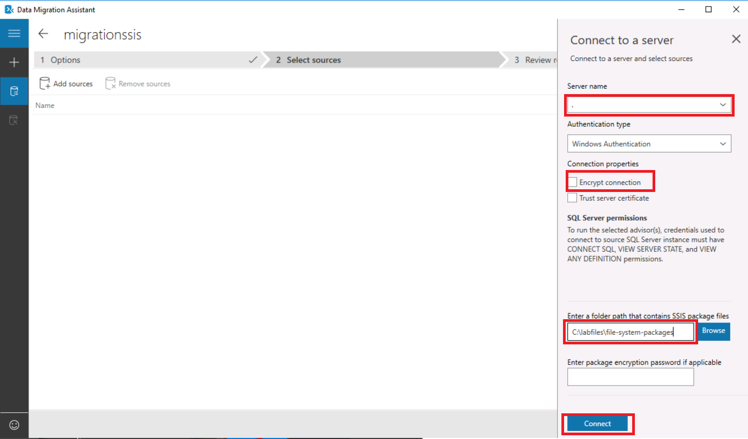

1. Check “File System” and “SSISDB”, then click “Add” the sources.

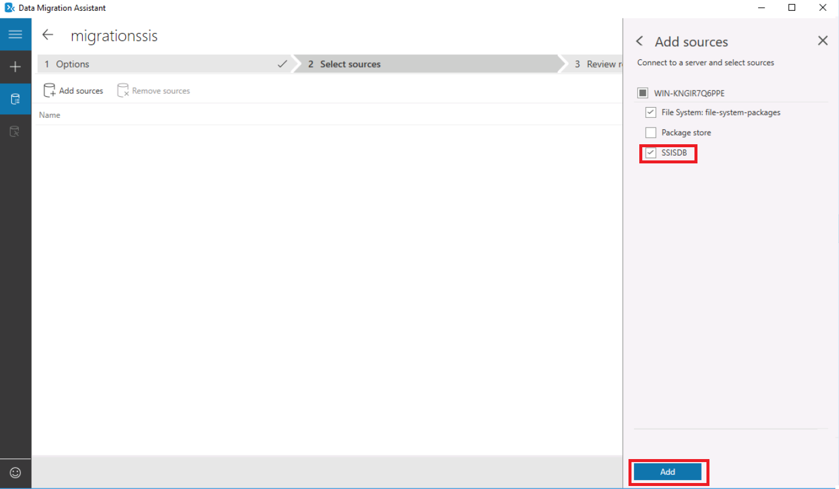

1. Click “Start Assessment”

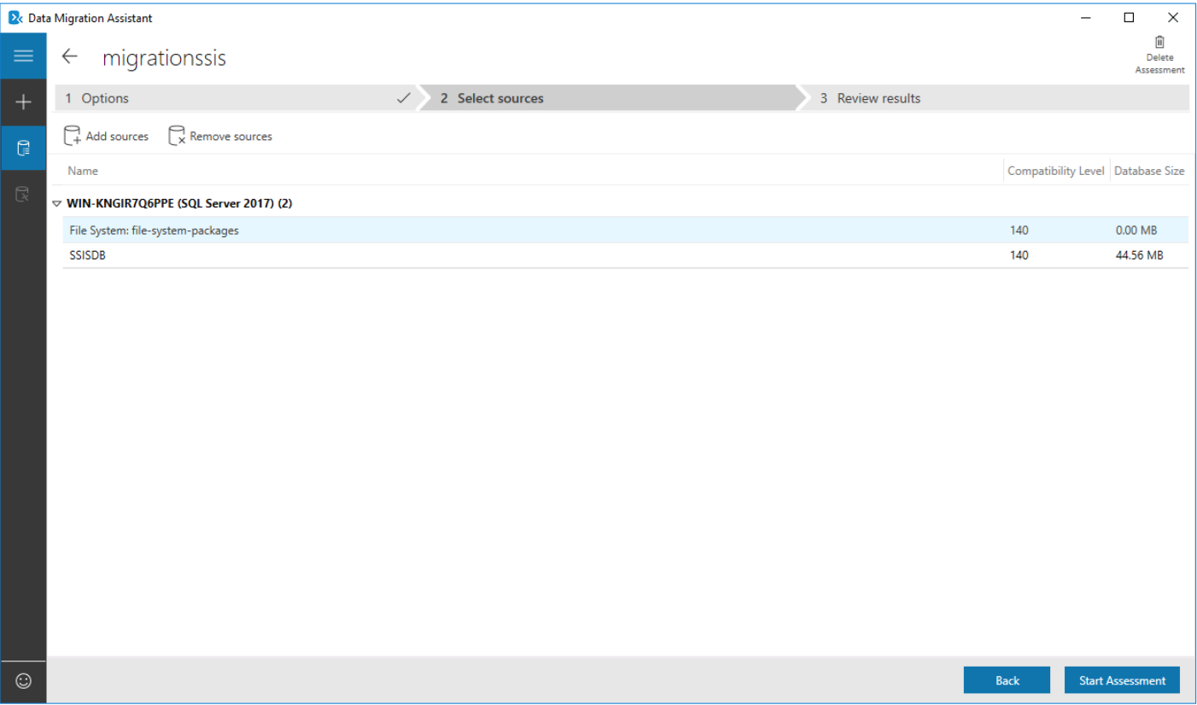

1. Check assessment results

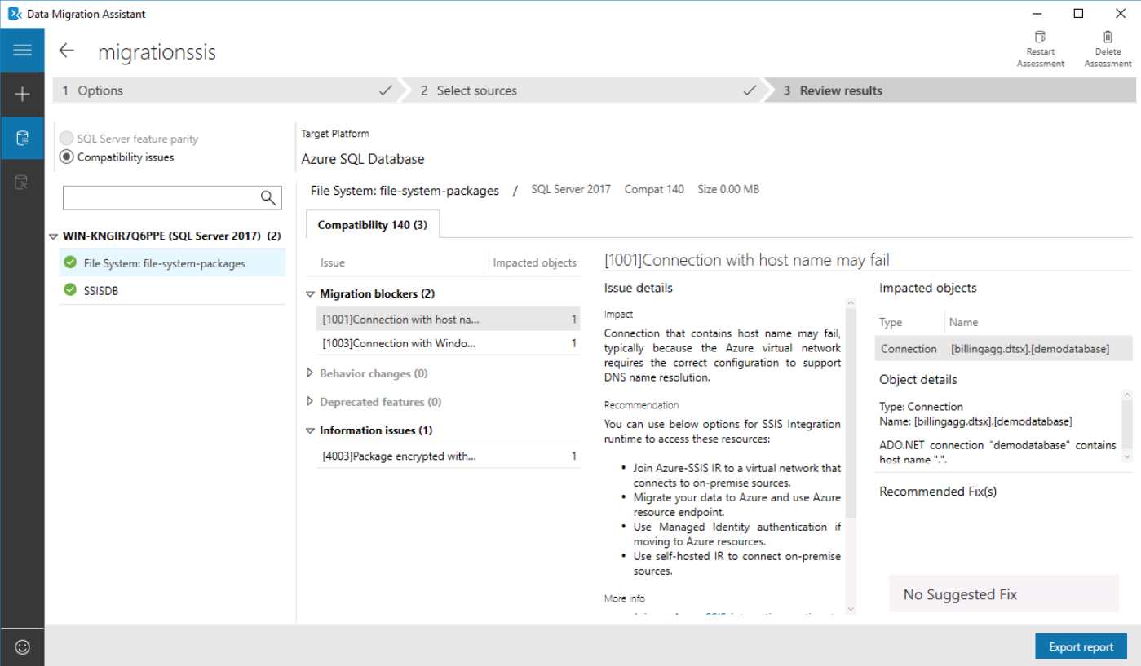

# Task 3: Design and execute package via SSDT Azure mode

In this task, you will use SSDT to execute package in SSIS Integration Runtime. The major steps include:

* Enable SSDT azure mode.
* Connect SSDT to a SSIS integration runtime which needs to select the subscription, Azure Data Factory, SSIS integration runtime, and a storage account that will be used for package execution logs. ADF, SSIS IR and storage account are all provisioned in Task 0.
* Change the package parameter data source server from localhost to Azure SQL Database, then execute package in Azure.

Reference: [Execute SSIS packages in Azure from SSDT](https://docs.microsoft.com/en-us/azure/data-factory/how-to-invoke-ssis-package-ssdt)

1. Launch SSDT, then open c:\labfiles\catalog project 2\catalog project2.sln, password is “Pa$$w0rd”

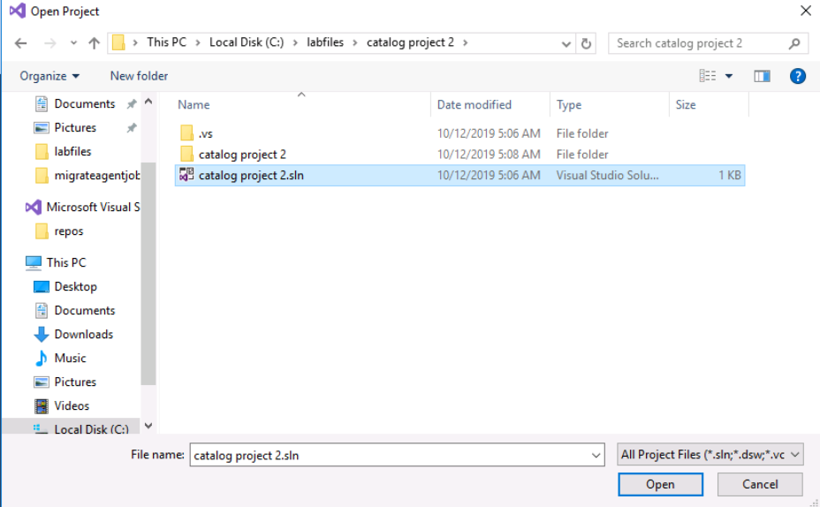

1. Right click project, then check “Azure-Enabled” to enable Azure mode.

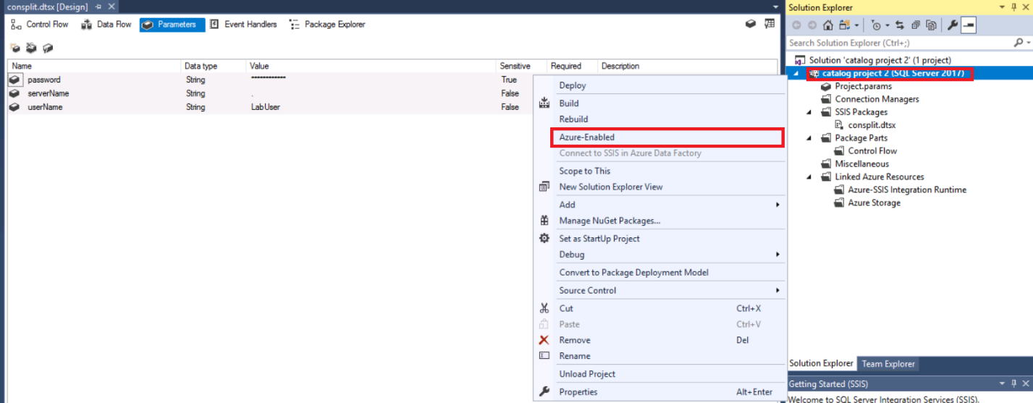

1. Click “Connect to SSIS in Azure Data Factory”, then select your subscription, data factory, Integration runtime, and storage account.

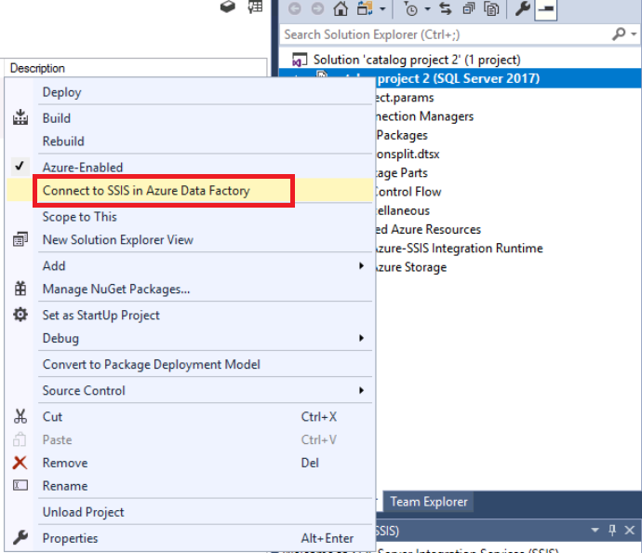

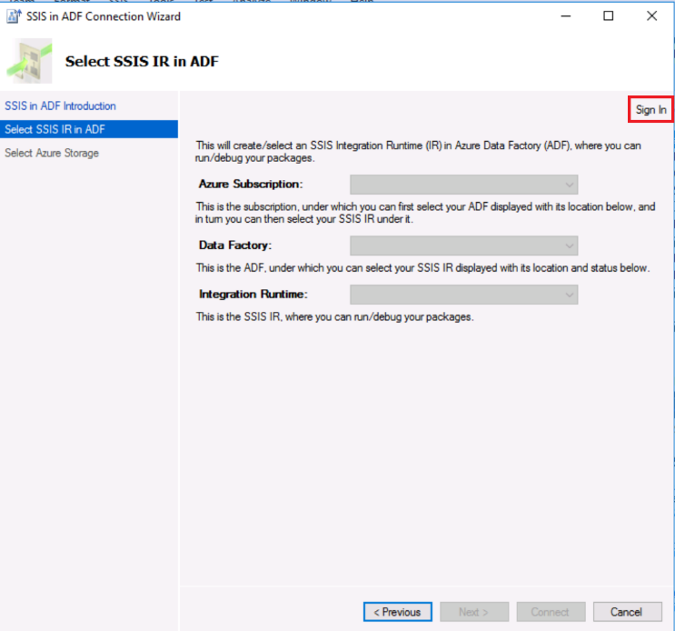

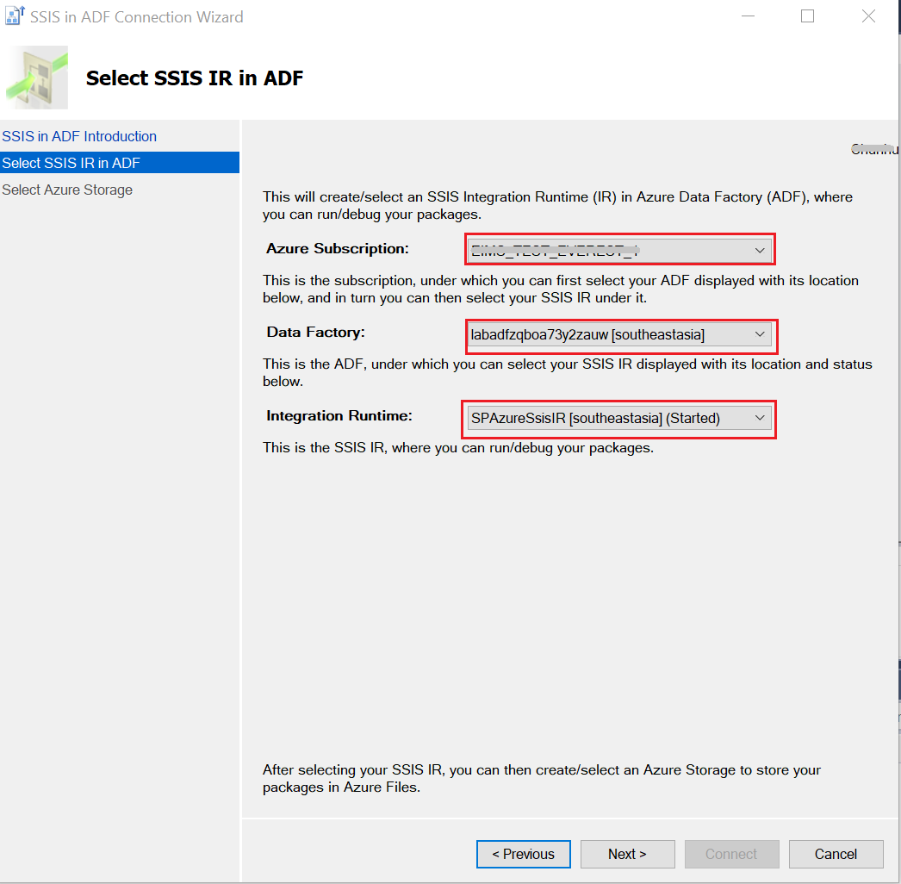

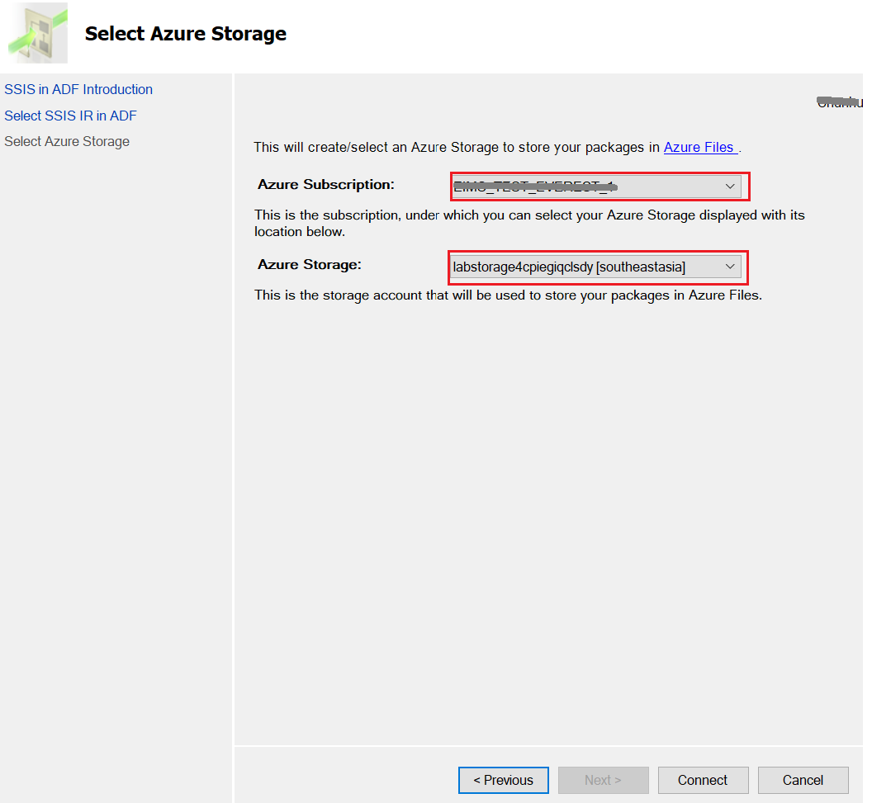

1. Configure parameter serverName to your Azure SQL Database server name. Then save project.

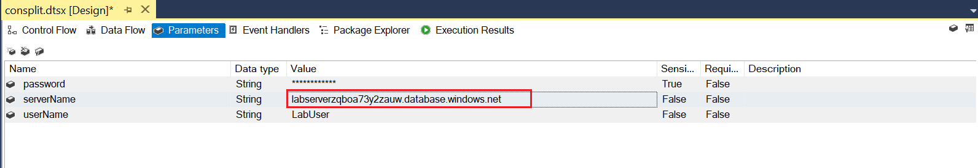

1. Execute Package in Azure

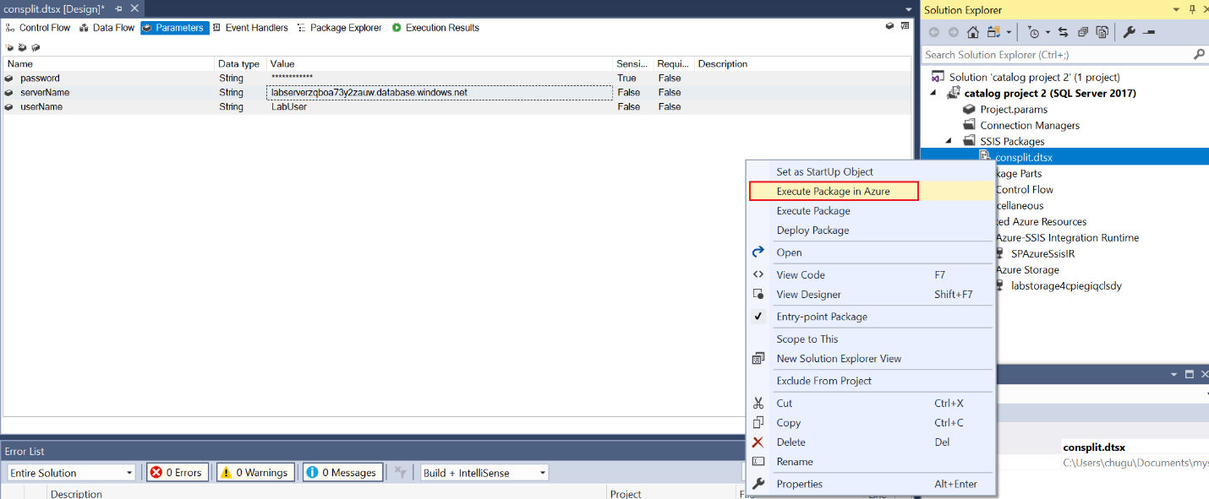

1. Check progress and execution logs under your storage account “[File shares](https://ms.portal.azure.com/#@microsoft.onmicrosoft.com/resource/subscriptions/cb715d05-3337-4640-8c43-4f943c50d06e/resourceGroups/adf-ssis-lab/providers/Microsoft.Storage/storageAccounts/labstorage4cpiegiqclsdy/fileList)” -> “[ssdtexecution](https://ms.portal.azure.com/#blade/Microsoft_Azure_FileStorage/FileShareMenuBlade/overview/storageAccountId/%2Fsubscriptions%2Fcb715d05-3337-4640-8c43-4f943c50d06e%2FresourceGroups%2Fadf-ssis-lab%2Fproviders%2FMicrosoft.Storage%2FstorageAccounts%2Flabstorage4cpiegiqclsdy/path/ssdtexecution)”

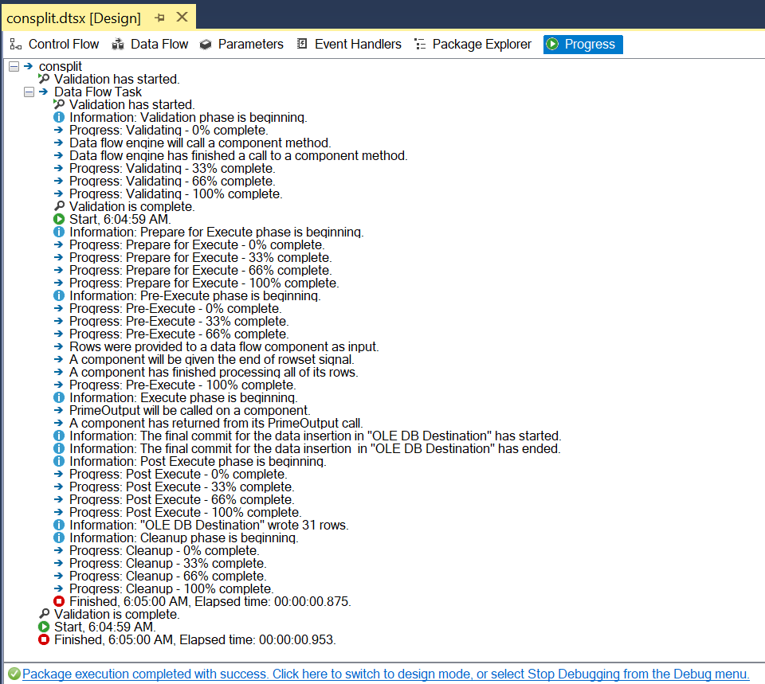

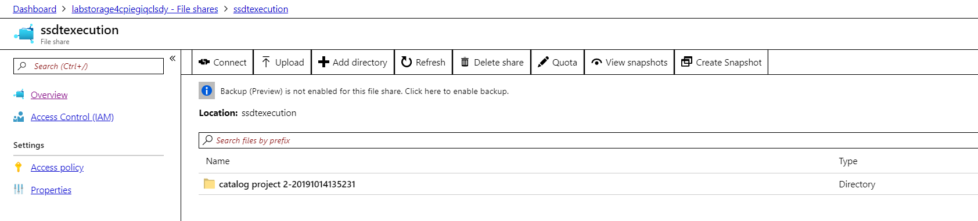

# Task 4: Migrate File System packages to Azure file share

In this task, you will migrate packages in file system c:\labfiles\ file-system-packages \billingagg.dtsx to Azure file share using DTUtil.

Reference: [dtutil Utility](https://docs.microsoft.com/en-us/sql/integration-services/dtutil-utility)

1. Get your storage account and access key

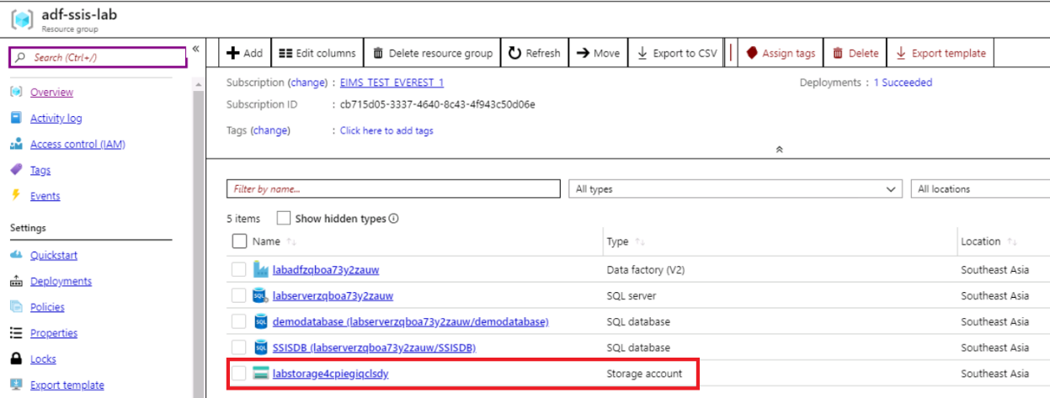

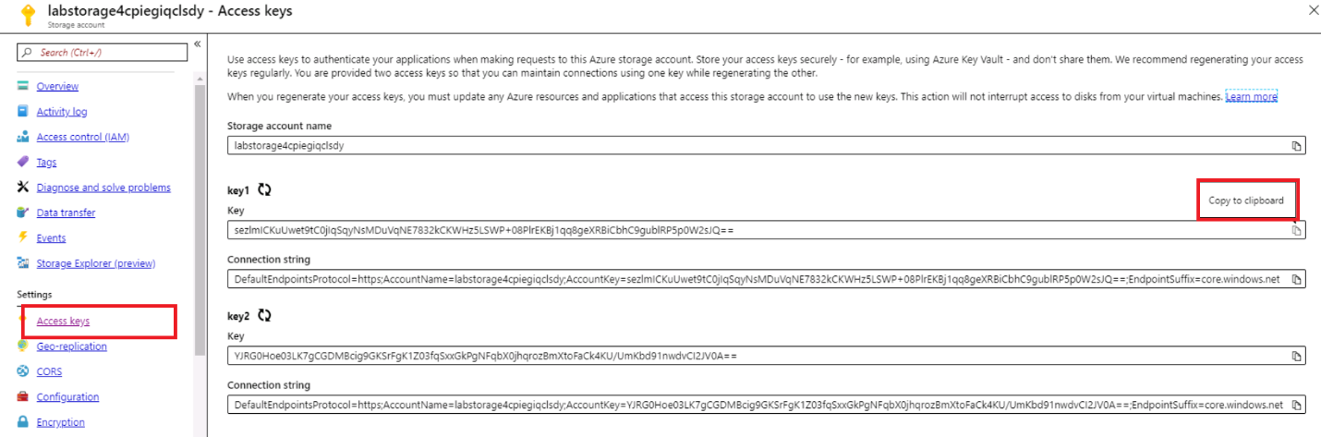

1. Open cmd terminal, replace with your provisioned storage account and access key, then run below command. All commands used are in c:\labfiles\cmds.txt.

cmdkey /add:labstorage4cpiegiqclsdy.file.core.windows.net /user:azure\labstorage4cpiegiqclsdy/pass:sezlmICKuUwet9tC0jIqSqyNsMDuVqNE7832kCKWHz5LSWP+08PlrEKBj1qq8geXRBiCbhC9gublRP5p0W2sJQ==

1. Run cmdkey /list: labstorage4cpiegiqclsdy.file.core.windows.net, verify the added credential.

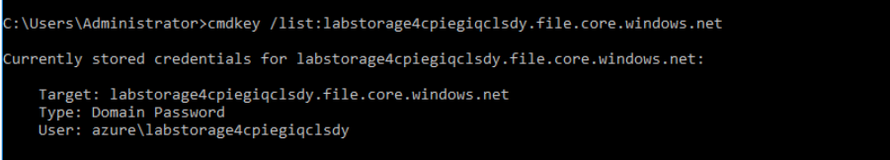

1. Run below command, replace with your storage account.

dtutil /File c:\labfiles\ file-system-packages \billingagg.dtsx /COPY File;\\labstorage4cpiegiqclsdy.file.core.windows.net\ssispackages\billingagg.dtsx

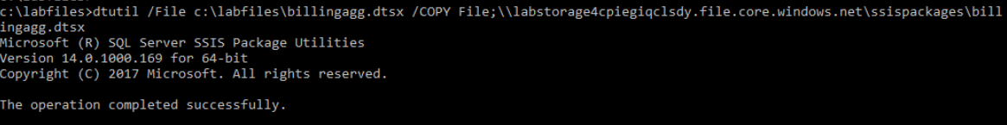

Package now is migrated to Azure File share in your storage account.

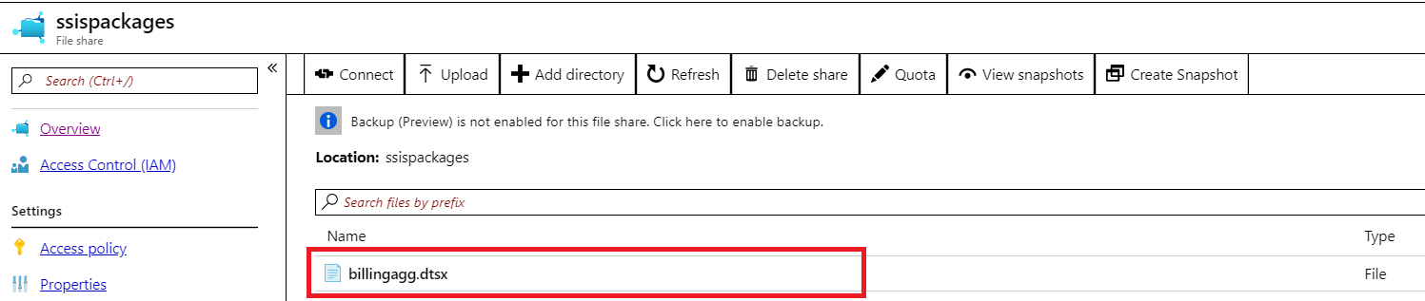

# Task 5: Execute File System package via AzureDTExec

In this task, you will execute File System package moved to Azure File Share in Task 4 using AzureDTExec.

Commands used in this task are in c:\labfiles\cmds.txt.

Reference: [Run SQL Server Integration Services packages with the Azure-enabled dtexec utility](https://docs.microsoft.com/en-us/azure/data-factory/how-to-invoke-ssis-package-azure-enabled-dtexec)

1. Create an App registration

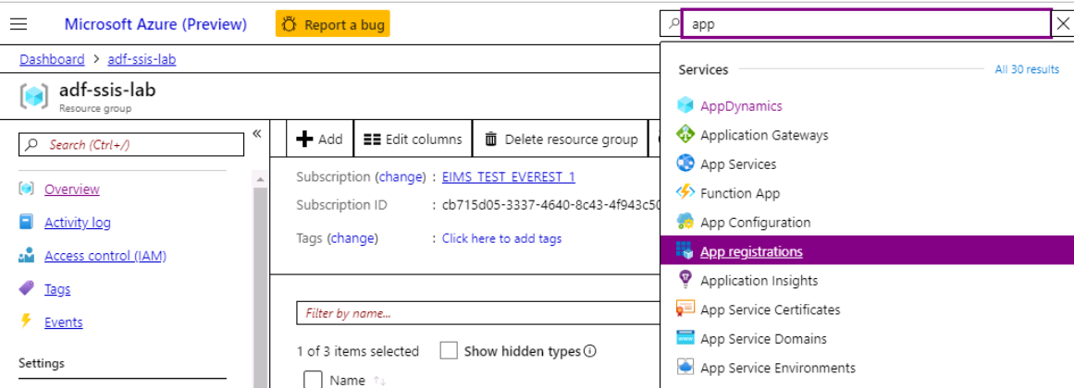

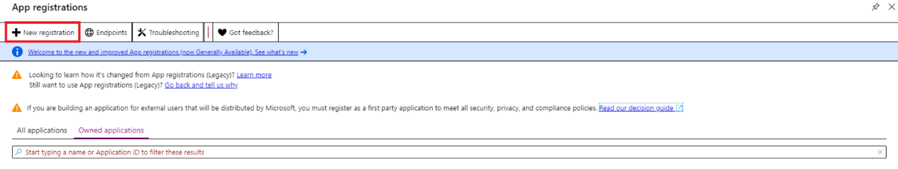

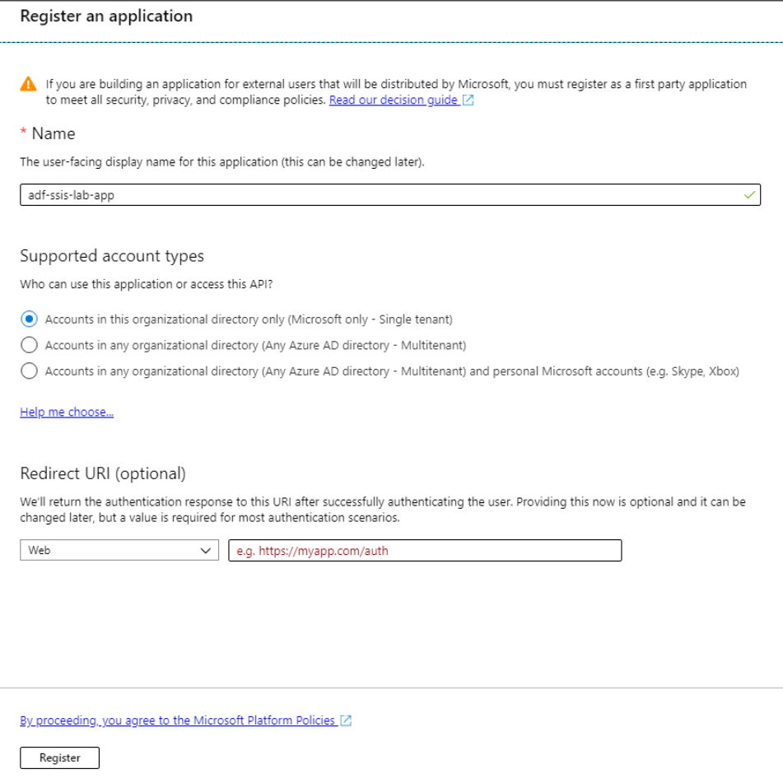

1. Get the “Application ID” and “tenant ID”, these will be used in step 5.

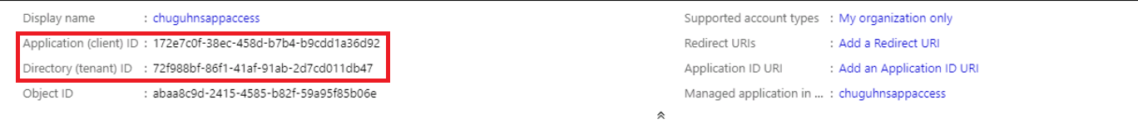

1. New client secrete, then copy secrete key to a file. Make sure you save the secrete key, this will be used in step 5.

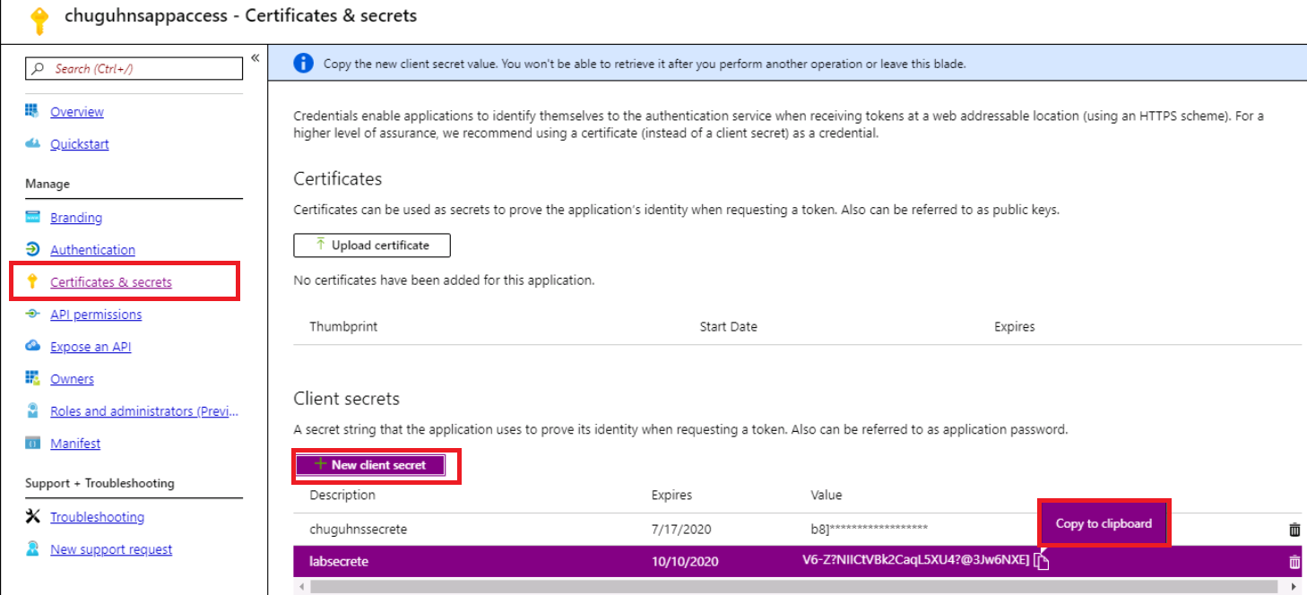

1. Authenticate ADF to access through SSMS application. Go to ADF resource, and assign role “Data Factory Contributor” Role to your registered app.

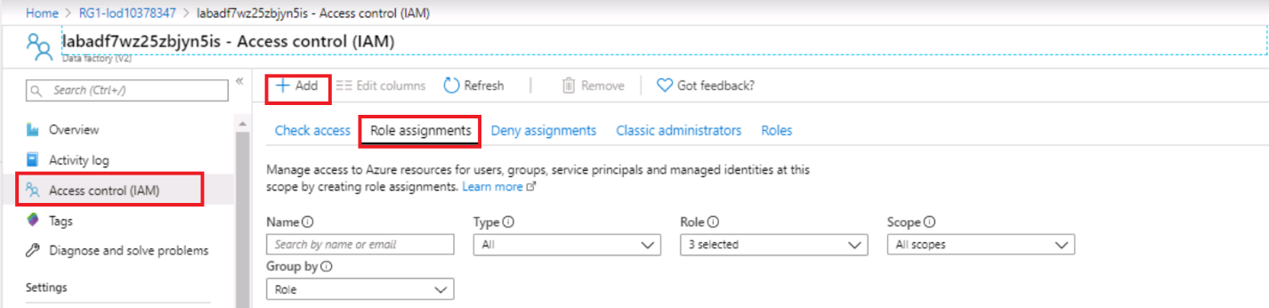

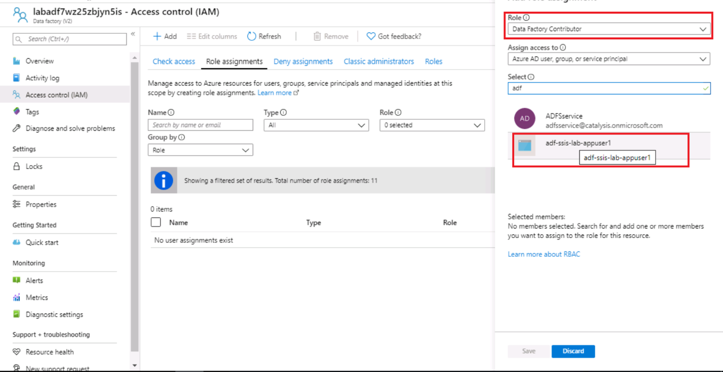

1. Open SSMS as an admin user, and click the button in SSMS under ‘Tools -> Migrate to Azure -> Configure Azure-enabled DTExec’. Then a UI which is for configuring AzureDTExec settings will be popped up.

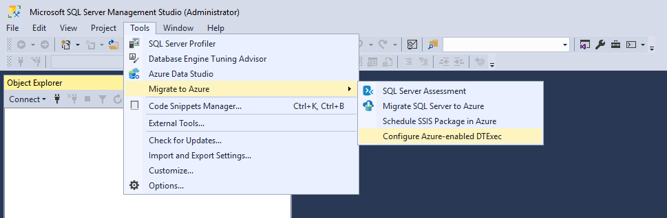

(Note:  This UI needs to be opened with an admin permission to write into the AzureDTExec settings file. If you don’t open it with an admin permission, then a  User Account Control (UAC) window will be popped up to ask for the admin password to elevate the permission.)

1. In the popup UI, fill in the property grid to give necessary information for AzureDTExec’s execution, then apply.

ApplicationId: from step 2 “Application ID”

AuthenticationKey: from step 2 “Client Secrete”

LogAccessDomain: Azure

LogAccessPassword: your storage access key

LogAccesUserName: Your storage account

LogLevel: Basic

LogPath: your storage UNC path. <storageacount>.file.core.windows.net\ssislogging

Package AccessDomain/AccessPassword/AccesUserName are same with Log

PipelineNameHashStrLen:32

Resourcegroup: resource group created in Task 0.

TenantId: App registration Tenant ID from step 2.

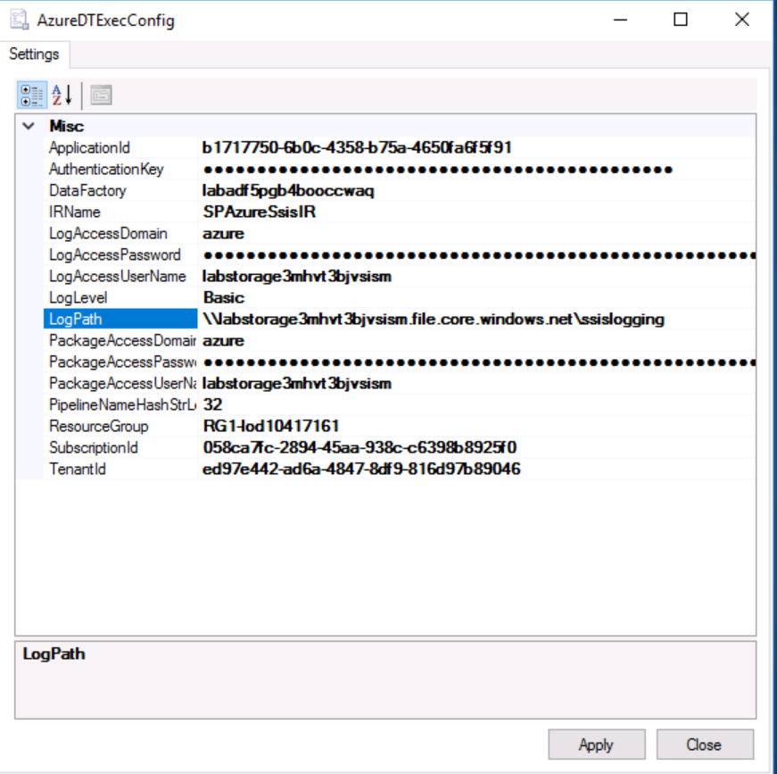

Note: this can be set under C:\Program Files (x86)\Microsoft SQL Server Management Studio 18\Common7\IDE\CommonExtensions\Microsoft\SSIS\150\Binn\AzureDTExec.settings

1. Run below commands to execute file package which is migrated to Azure file share in Task 5. Replace with storage account provisioned in Task 0.

cd C:\Program Files (x86)\Microsoft SQL Server Management Studio 18\Common7\IDE\CommonExtensions\Microsoft\SSIS\150\Binn

.\AzureDTExec.exe

/F \\labstorage4cpiegiqclsdy.file.core.windows.net\ssispackages\billingagg.dtsx

Note: Package execution failed, due to package migrated is using windows authentication for connection manager.

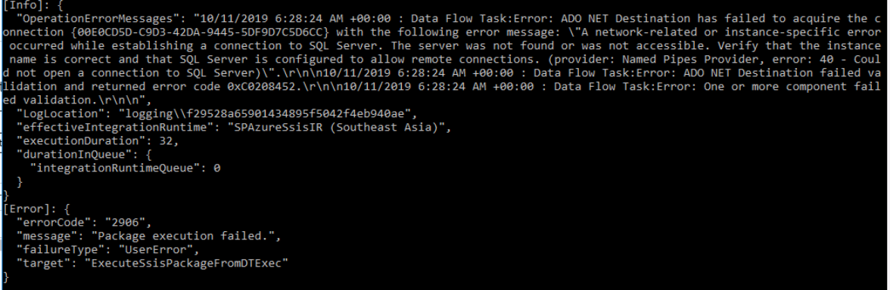

1. Run below commands with SQL authentication for connection manager, replace with storage account and Azure SQL server provisioned from Task 0.

.\AzureDTExec.exe

/F \\labstorage4cpiegiqclsdy.file.core.windows.net\ssispackages\billingagg.dtsx

/Conn "demodatabase; Data Source=labserverzqboa73y2zauw.database.windows.net; User ID=LabUser; Password=pa$$w0rd; Initial Catalog=demodatabase;"

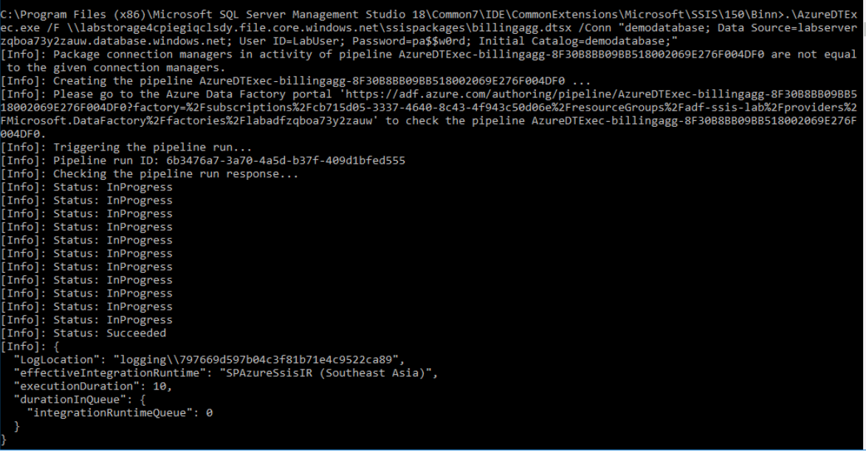

1. Monitor package execution in ADF portal.

A pipeline was created.

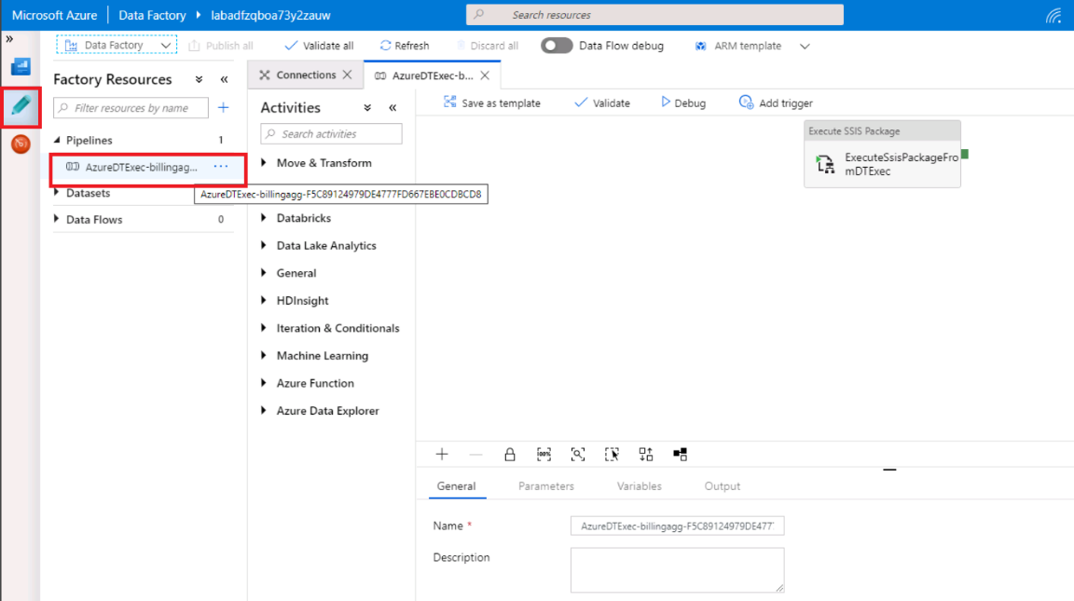

Two runs were executed.

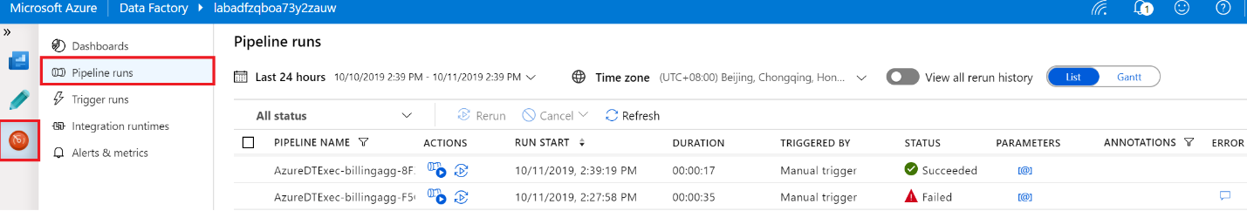

# Task 6: Execute File System package via ADF pipeline

In this step you will manually create an ADF pipeline to execute File System package that you migrated Azure File Share in step 4.

Reference: [Run an SSIS package with the Execute SSIS Package activity in Azure Data Factory](https://docs.microsoft.com/en-us/azure/data-factory/how-to-invoke-ssis-package-ssis-activity)

1. Go to ADF authoring portal, click pen icon then click “+” “Pipeline” to create a new pipeline

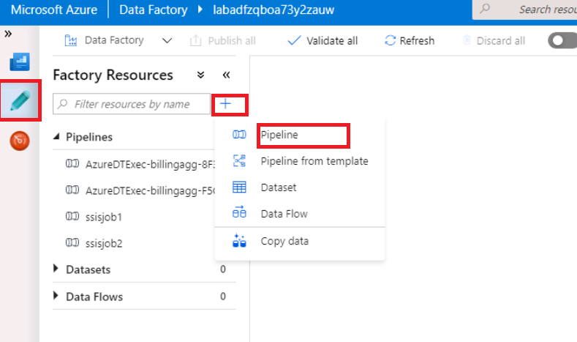

1. Drag “Execute SSIS Package” activity and drop in canvas.

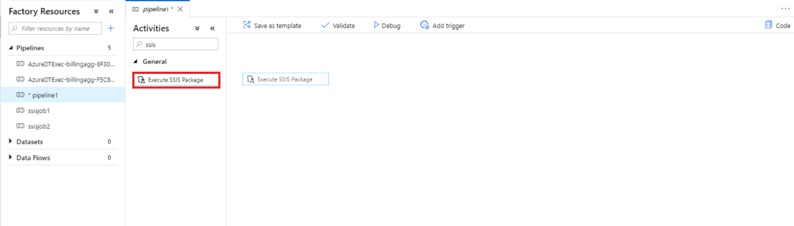

1. Configure pipeline setting as below.

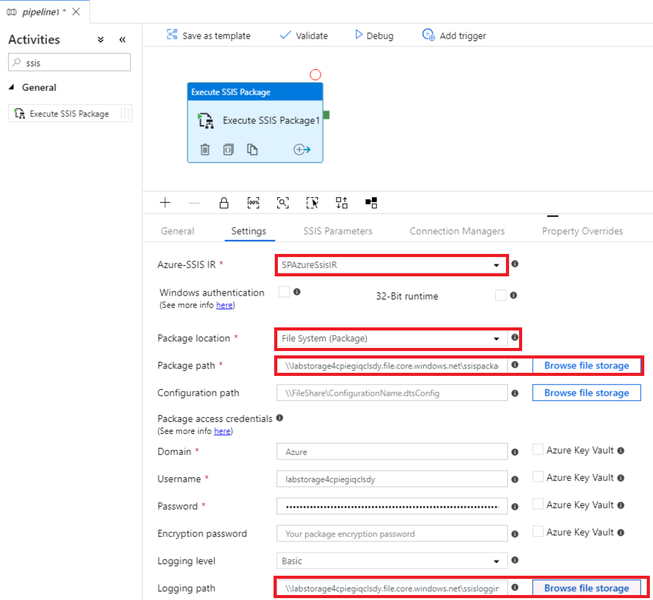

1. Configure “Connection Managers” as blow, replace Data source with Azure SQL server provisioned in Task 0.

* Click “+” to add a property to override package definition.
* Scope: Package
* Name: demodatabase
* Property: ConnectionString
* Value: Data Source=labserverzqboa73y2zauw.database.windows.net; User ID=LabUser; Password=Pa$$w0rd; Initial Catalog=demodatabase;

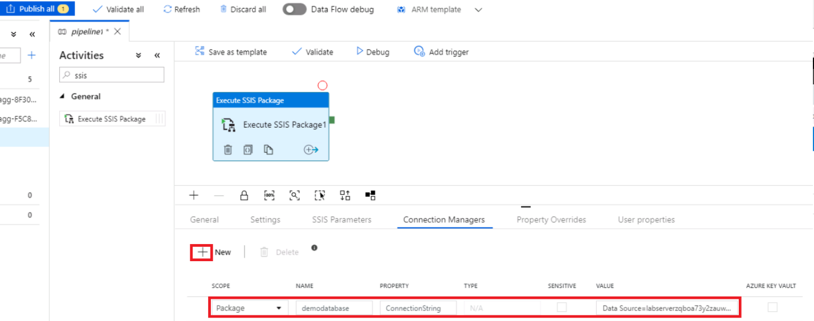

1. Publish pipeline, then you will get “Publishing completed” notification.

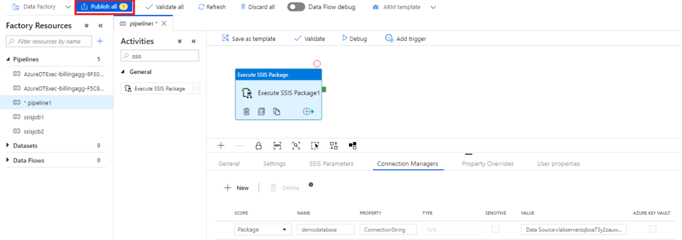

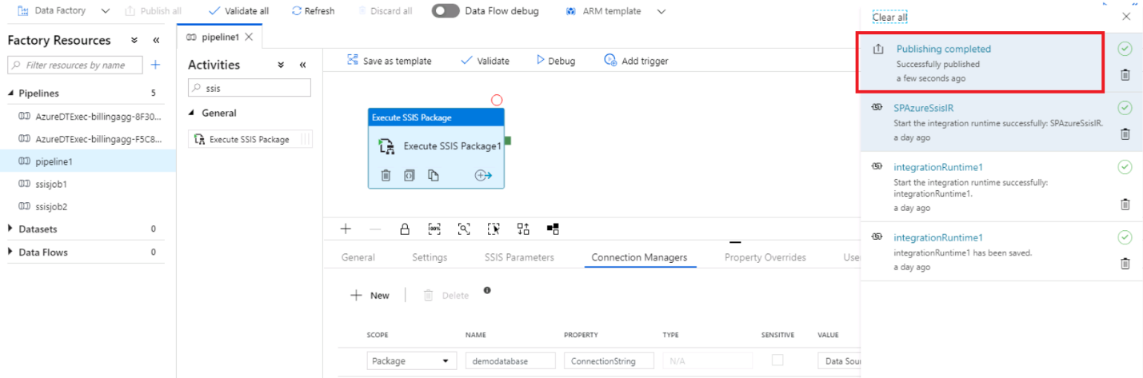

1. Trigger an on-demand run by click “Trigger now”.

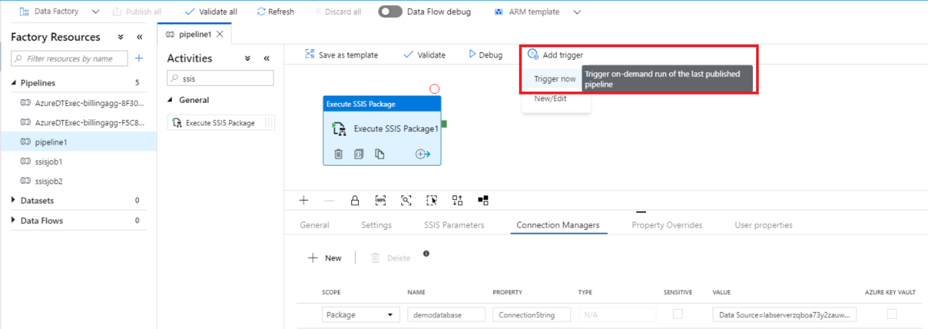

1. Click Monitor icon, then click “Pipeline runs” to monitor triggered runs.

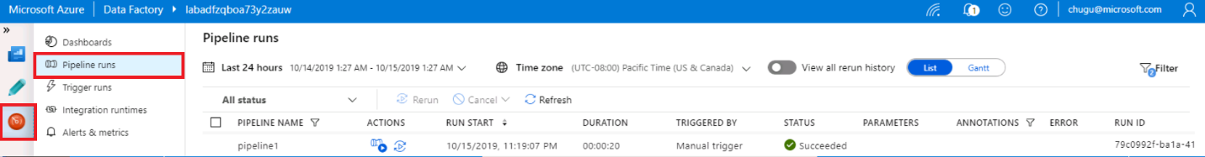

1. Check detail package execution logs under your storage account.

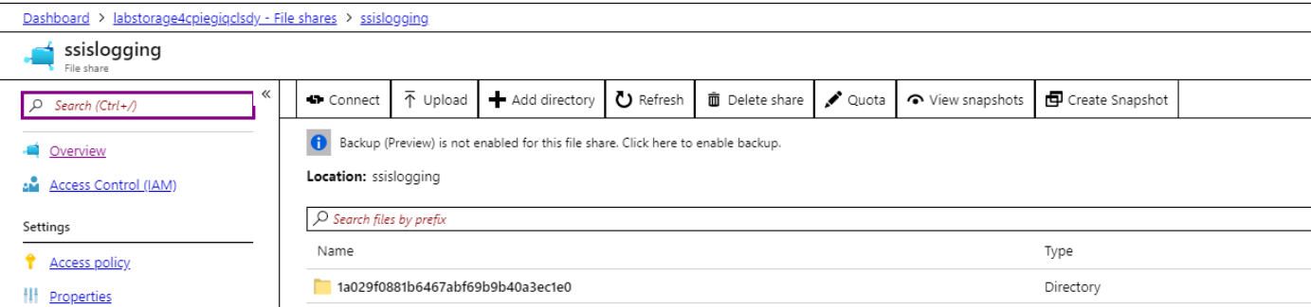

# Task 7: Deploy File System packages via ARM template to ADF pipeline

In this task, you will use ARM template to deploy File System packages to ADF pipeline, then execute.

Reference: [Pipeline Json file](https://docs.microsoft.com/en-us/azure/data-factory/how-to-invoke-ssis-package-ssis-activity#run-a-package-with-powershell)

1. Deploy a custom template, click [Build your own template in the editor](https://ms.portal.azure.com/).

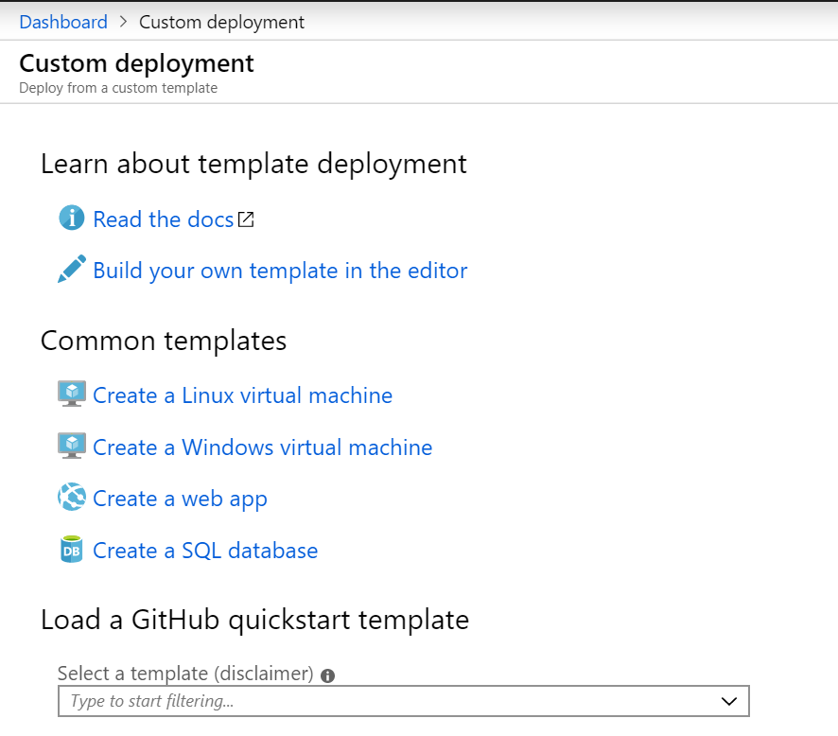

1. Load “adf_pipeline_deploy” and save.



1. On the custom deployment screen in the Azure portal, enter the following:

* **Subscription**: Select the subscription you are using for this hands-on lab.
* **Resource group**: Select the resource group used for this lab.
* **Factory Name**: Input the factory name create from Task 0.
* **Database_server Name:** Input the database server name create from Task 0.
* **Database_user Name**: Accept the default value if you used default user name for database in Task 1. Otherwise input the database user name.
* **Database_password**: Accept the default value if you used default password for database in Task1. Otherwise input the database password.
* **Storage_account Name**: Input the storage account name created from Task 0.
* **Storage_key**: Input the storage access key.
* Check the box to agree to the Azure Marketplace terms and conditions.

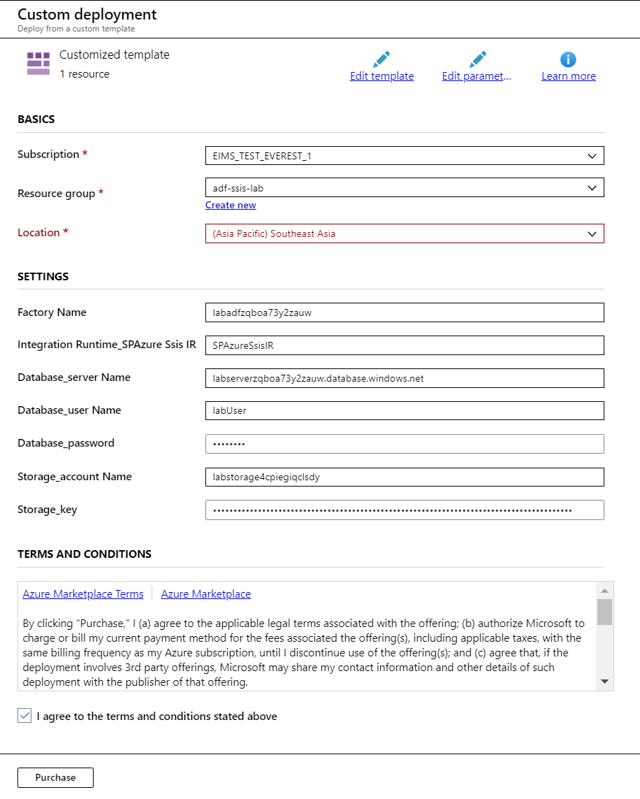

1. Deployment status, it will complete in seconds.

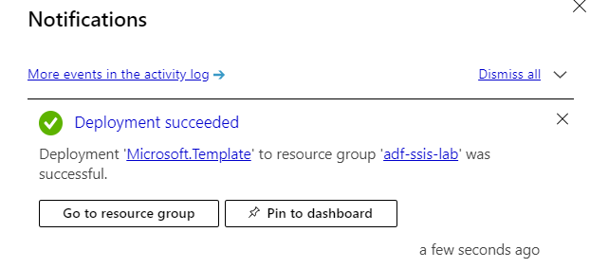

1. Go to Data Factory authoring window, click refresh. “ssis-file-package” pipeline is created.

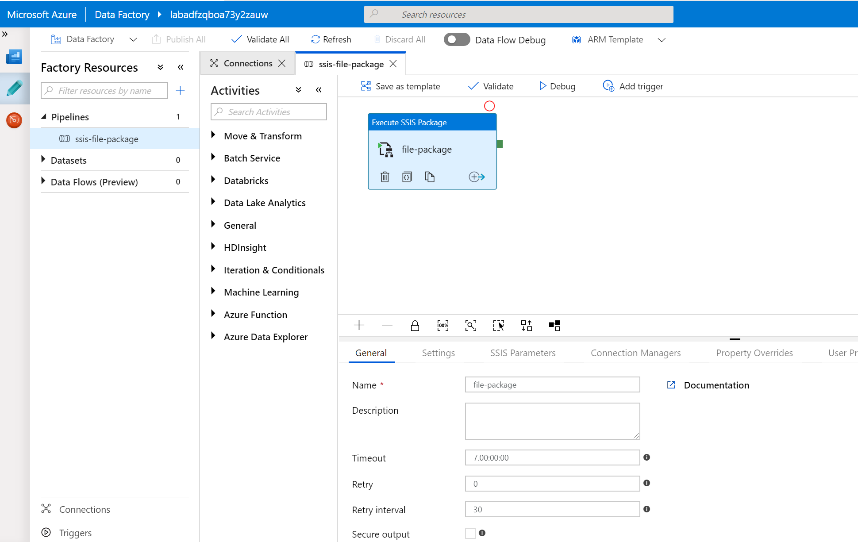

1. Trigger pipeline.

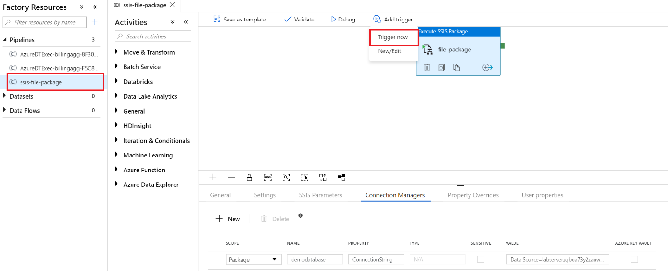

1. Monitor Pipeline Runs. Triggered pipeline “ssis-file-package” is in-progress now.

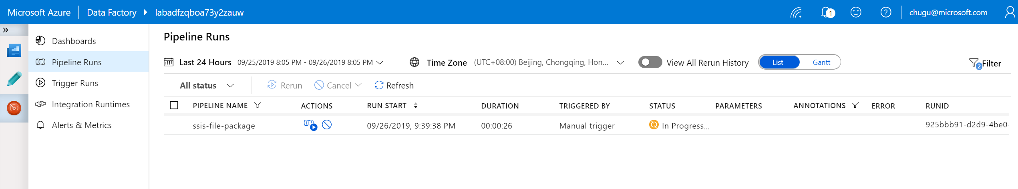

1. Check logging in storage File Share

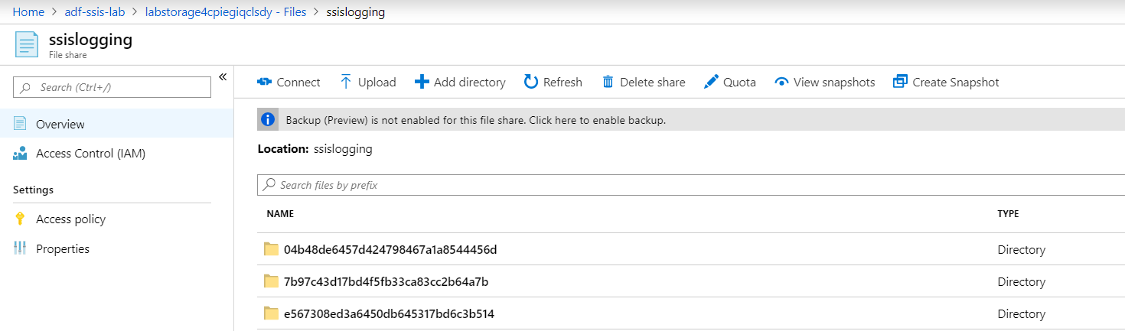

# Task 8: Migrate SSIS projects to SSIS IR in ADF

In this task, you will migrate SSIS catalog from localhost SSISDB to SSISDB in Azure SQL Database.

1. Open SSMS, connect to localhost SSISDB, there are two folders and two catalog projects. The next steps will migrate these projects to SSISDB in Azure SQL Database.

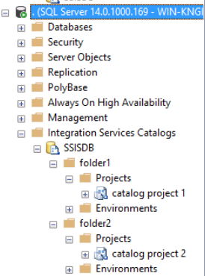

1. Go to resource group “adf-ssis-lab”, select “SQL server”, then copy “Server name”



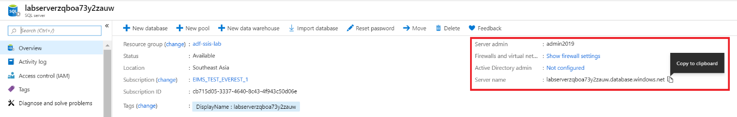

1. Open “SSMS”, connect with “SQL Server Authentication” and Connect to database “SSISDB”.

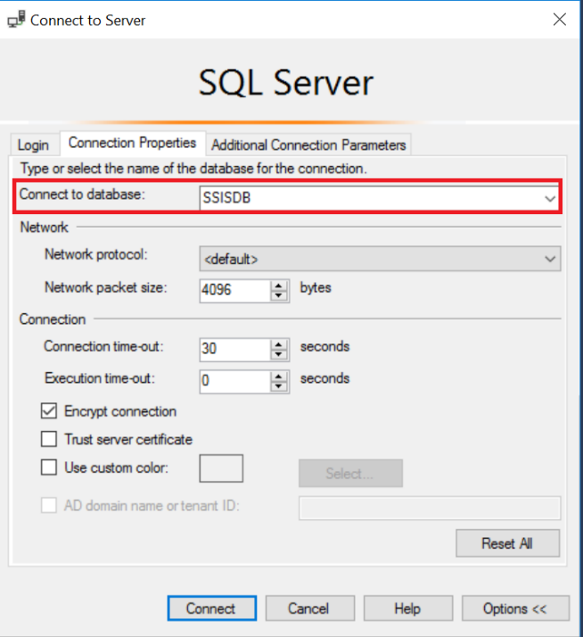

1. You will be prompted to create firewall rule to enable this client ip to access the server, if you have not done this yet.

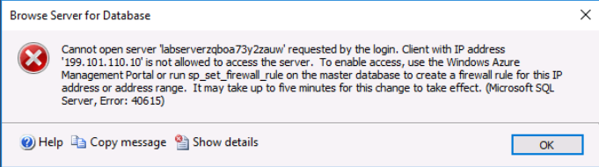



1. SSMS connects SSISDB successfully.

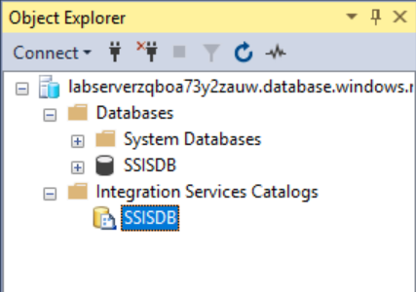

1. Go to C:\labfiles, right click “migrateCatalogProjects.ps1”, then “Edit”

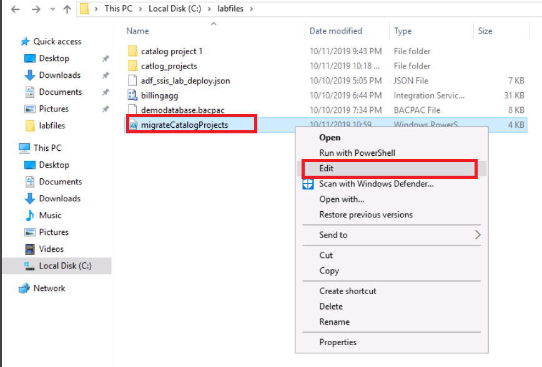

1. Replace <servername> with target database name hosting SSIS catalog

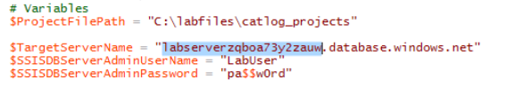

1. F5 Run script, you will see success status.

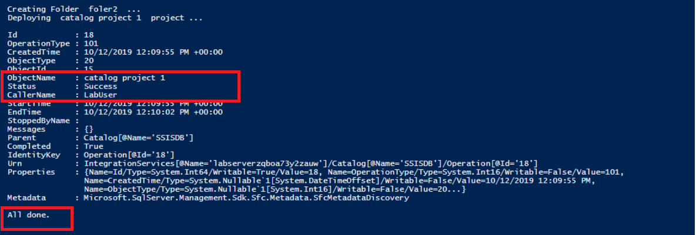

1. Validate projects deployed through SSMS

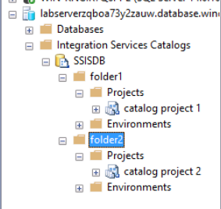

# Task 9: Migrate SSIS jobs to ADF

In this task, you will migrate SSIS SQL jobs from local SQL server to ADF scheduler.

1. Open SSMS, connect to localhost SQL server, there are two ssis jobs (job name should be with “ssisjob” prefix. The next few steps will migrate these jobs to ADF pipeline and schedules.

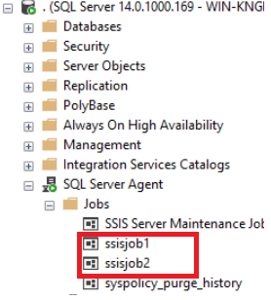

1. Go to c:\labfiles\migrateagentjobs, edit “jobMigrationSQLagent2ADF.ps1” with PowerShell Editor, then update “AzureDBName”, “SubscriptionName” and “DataFactoryName” with your own name.

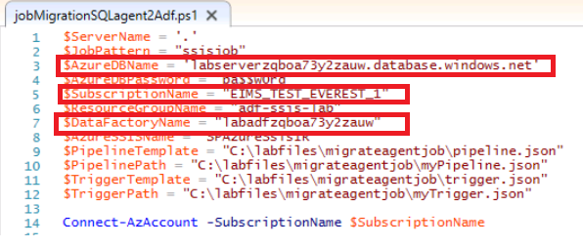

Alternatively: You can connect to your subscription and save context beforehand, then comment out the Connection-AzAccount command in the script. Which will avoid to sign-in account every time.

Enable-AzContextAutosave

Connect-AzAccount -SubscriptionName 'subscriptionname'

1. Run script, and check outputs.

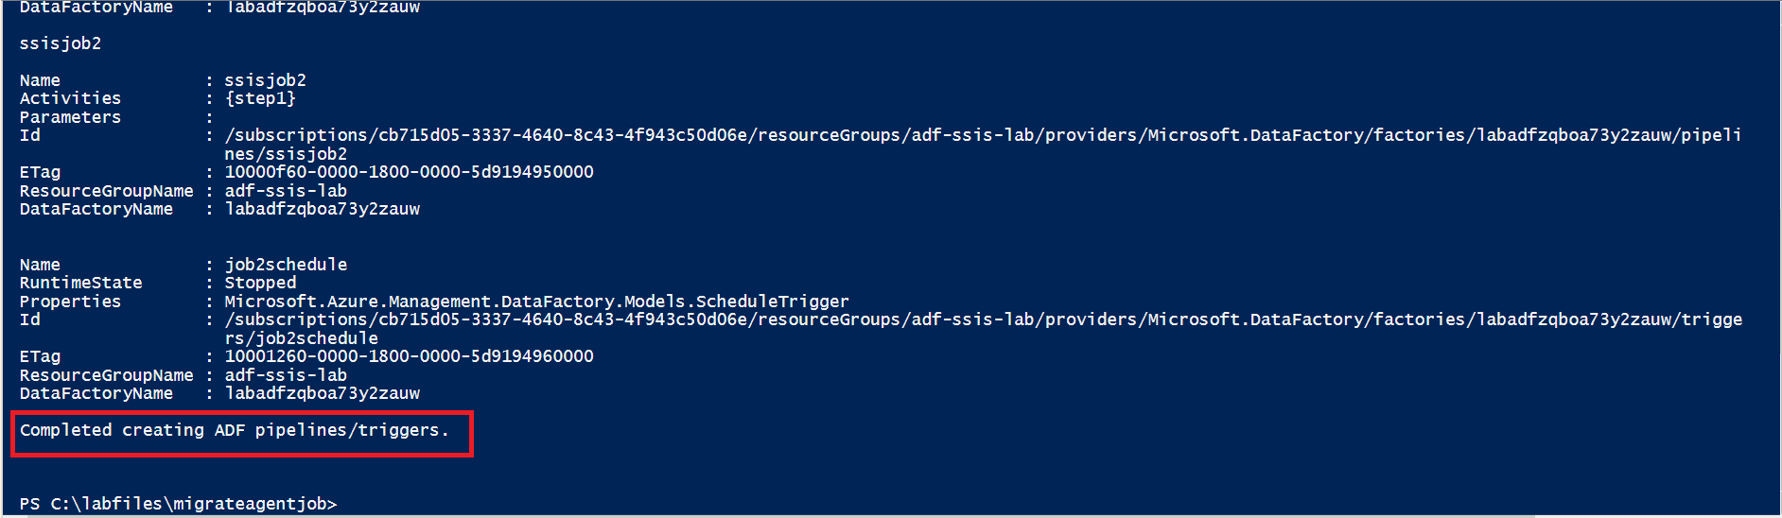

1. Go to ADF authoring page, “ssisjob1” and “ssisjob2” pipelines are created.

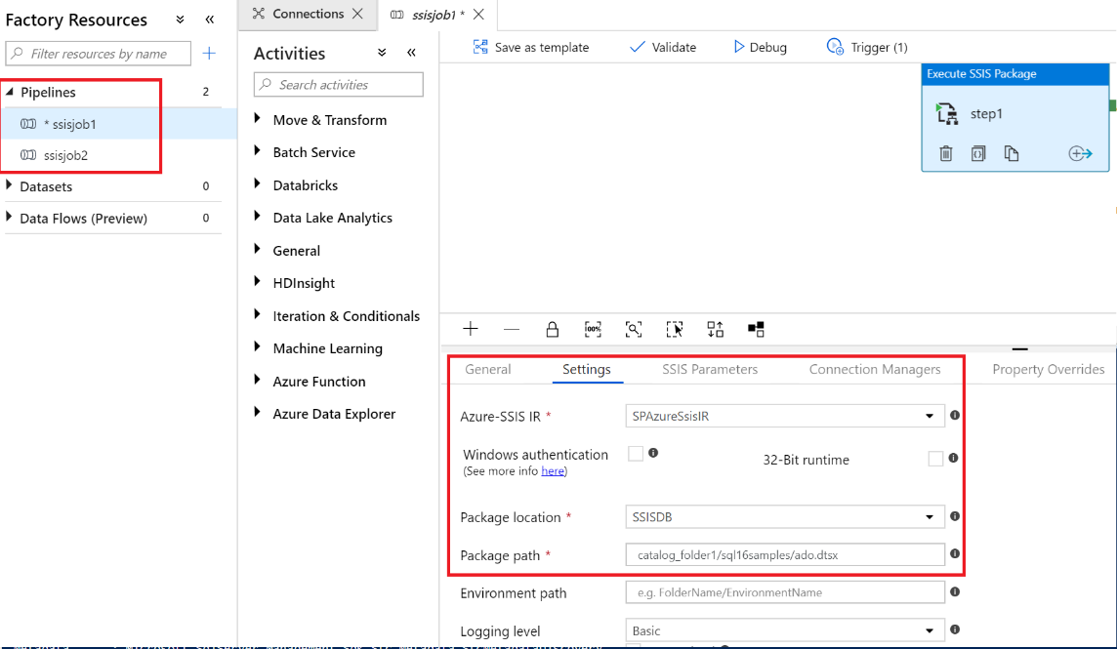

1. “ssisjob1schedule” and “ssisjob2schedule” are created.

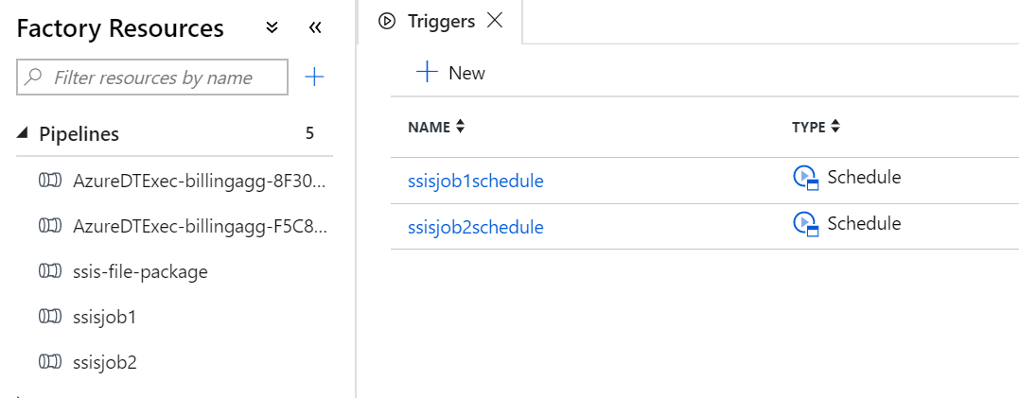

# Task 10: Clean up all Azure resources

In this task, all Azure resources provisioned during this lab are deleted.

1. Stop SSIS IR

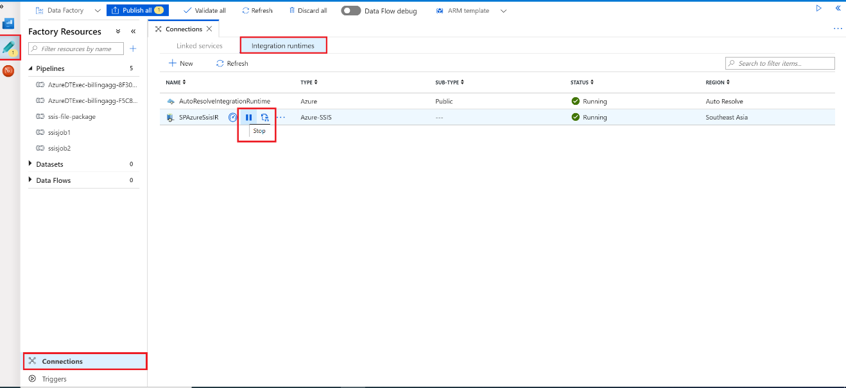

1. Delete resource group after SSIS IR is stopped. You will get notification when the resource group is deleted.

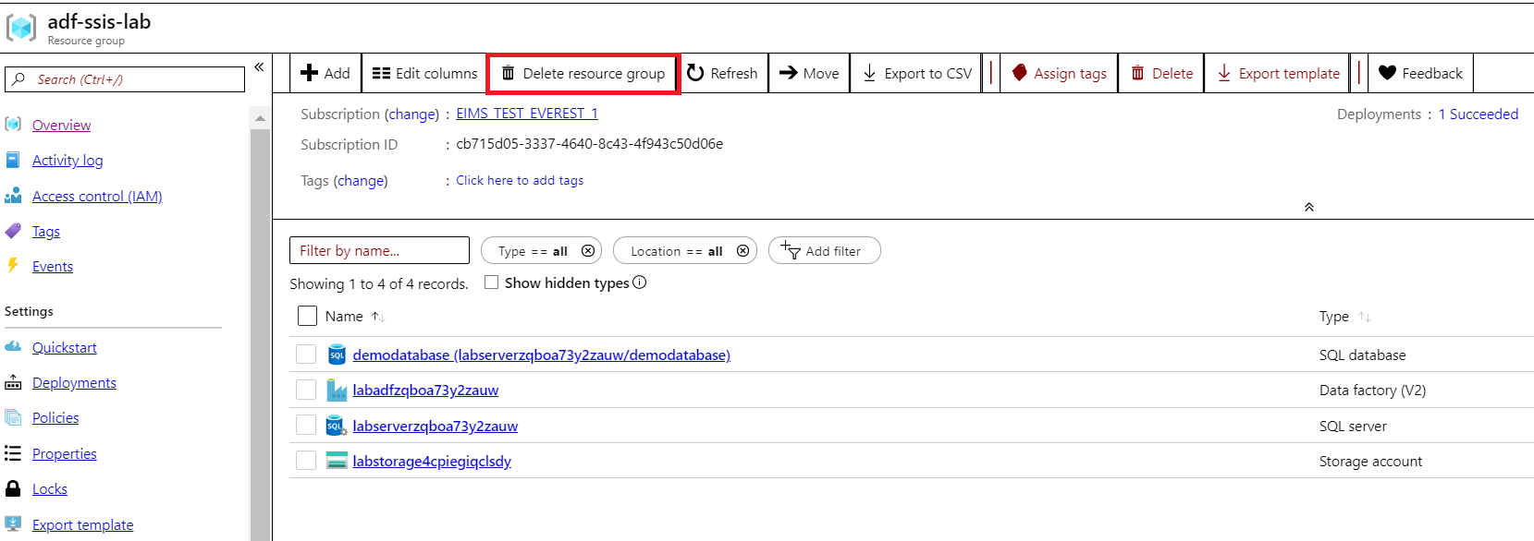

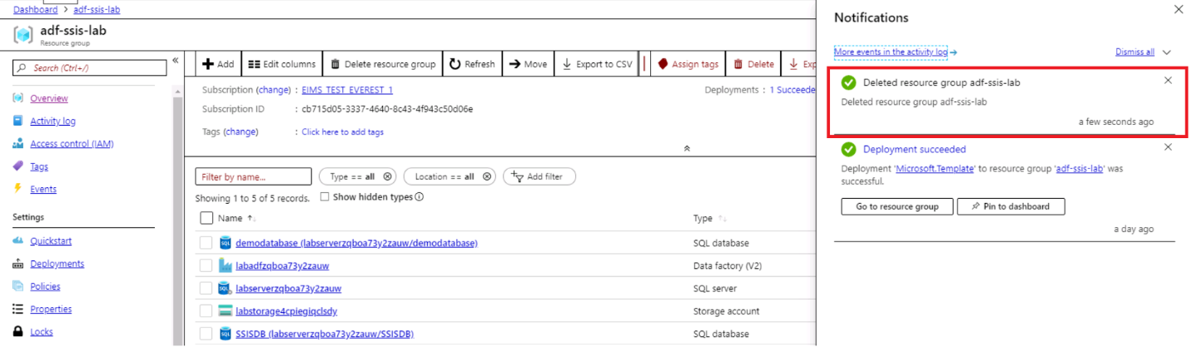

# Appendix

## Before the lab

Before the lab, you should have below resources on your local server:

* SSSM latest version
* SSDT for VS 2017
* Data Migration Assistant

https://www.microsoft.com/en-us/download/details.aspx?id=53595

* Powershell with Az module

Install-Module -Name Az -AllowClobber -Scope AllUsers

* SQL server with SSIS catalogs and SSIS jobs configured. You can
  + Import demodatabase.bacpac
  + Deploy SSIS projects under “catalog project 1” and “catalog project 2” to server.
  + Create SSIS jobs with prefix “ssisjob” in job name, and each job has a schedule with name like ssisjob1schedule.

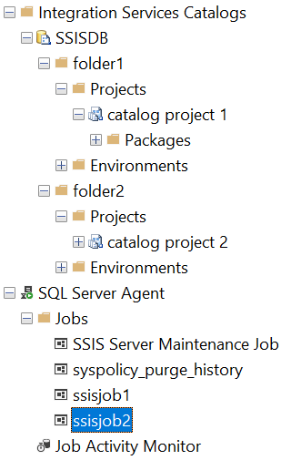

## Reference links

**Create SSIS Integration Runtime in ADF**

<https://docs.microsoft.com/en-us/azure/data-factory/create-azure-ssis-integration-runtime>

**Customize setup for the Azure-SSIS integration runtime**

<https://docs.microsoft.com/en-us/azure/data-factory/how-to-configure-azure-ssis-ir-custom-setup>

**Schedule the execution of SSIS packages deployed in Azure with SQL Server Management Studio (SSMS)**

<https://docs.microsoft.com/en-us/sql/integration-services/lift-shift/ssis-azure-schedule-packages-ssms?view=sql-server-2017>

**Migrate on-premises SSIS workloads to SSIS in ADF**

<https://docs.microsoft.com/en-us/azure/data-factory/scenario-ssis-migration-overview>